CAT4 Recipe – Pregnant patients with missing/overdue influenza and pertussis
In filter section, select active (3x in 2yrs).
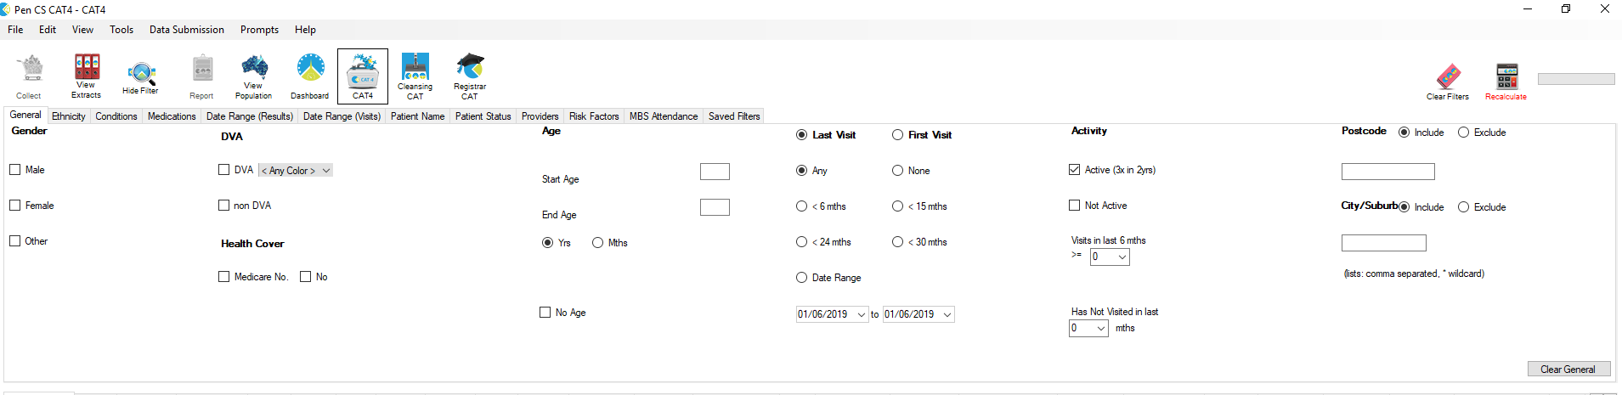
Go to the Risk Factors tab and select Pregnancy. Hit Recalculate.
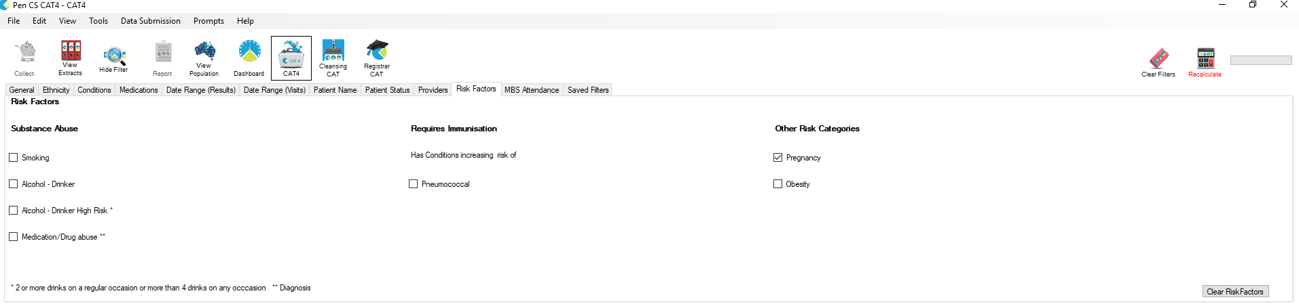

In the report section, click the Immunisations tab which opens to influenza. Click on the graph to select sections of ‘Previous Year’, ‘Prior to Previous Year’ and ‘Nothing Recorded’.
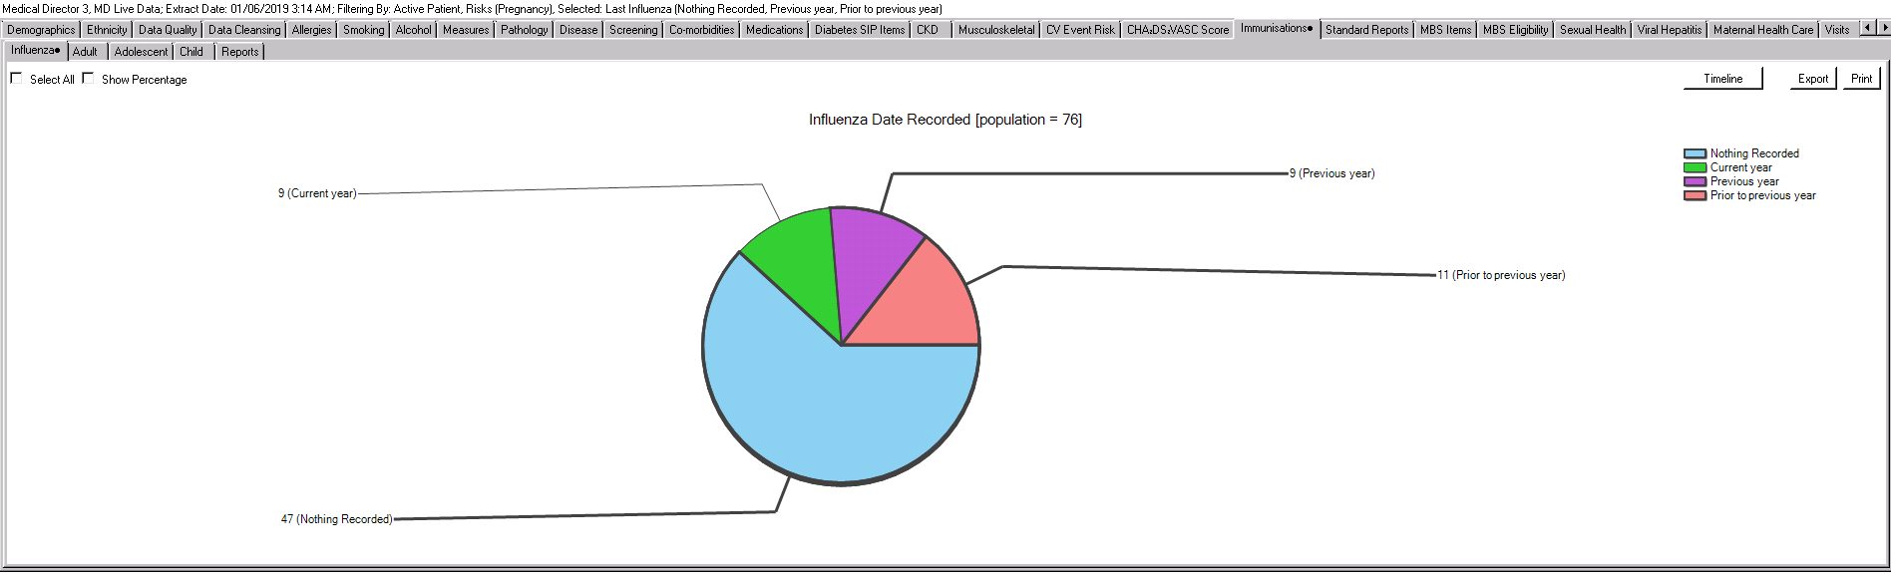
Remaining in the immunisations tab, select the Adult tab and click on Pertussis. Click on the graph to select all areas/segments.
Note – Current guidelines recommend pertussis immunisation for every pregnancy. A single dose of pertussis vaccine is strongly recommended for pregnant women in the third trimester of every pregnancy (preferably between 20 and 32 weeks but can be any time in the final trimester), whilst influenza vaccination timing is usually at diagnosis of pregnancy and at least before the influenza season, but can also occur at any time. Please also check the Australian Immunisation Register. Ref: Australian Immunisation Handbook
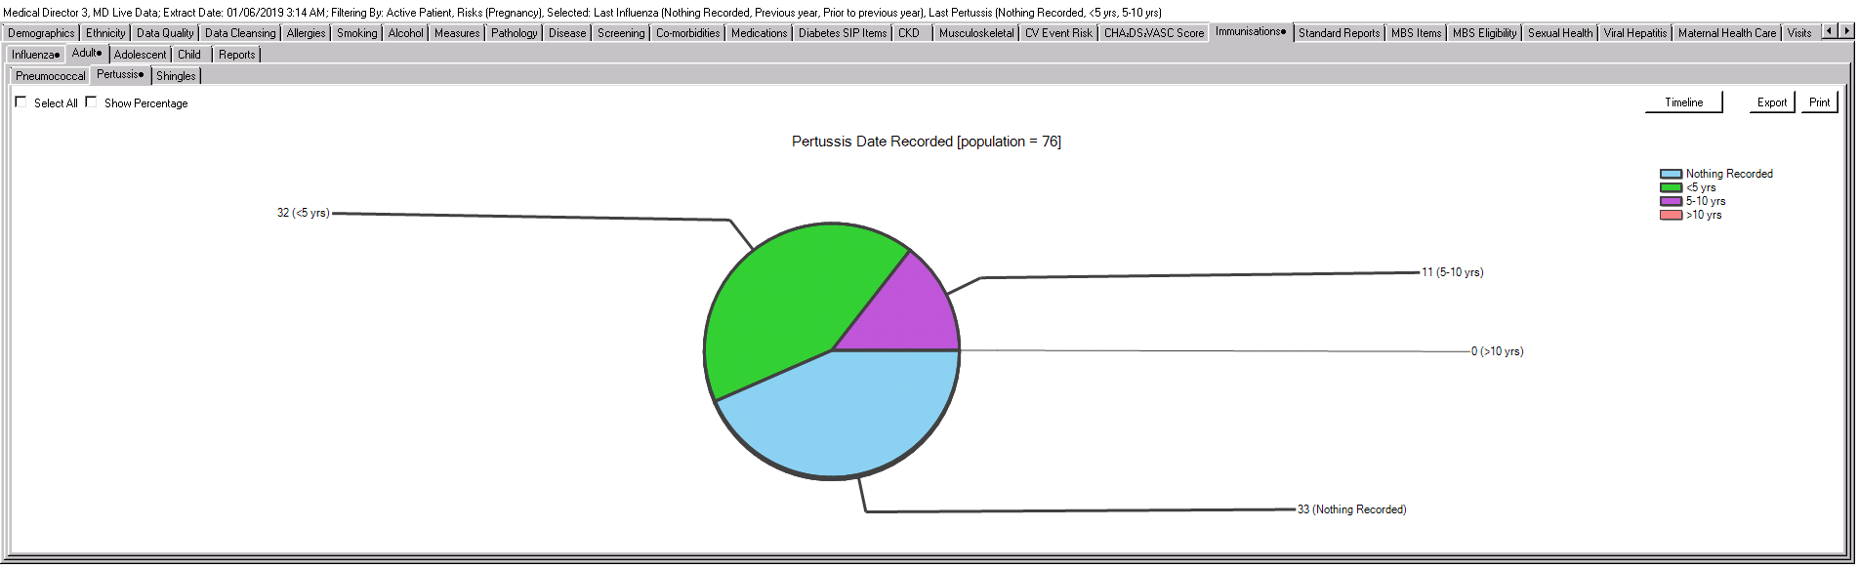
Select Report at the top of screen. A list will generate of pregnant patients with missing/overdue influenza and pertussis.
