CAT4 Recipe – 6 month – 5 years without influenza vaccinations recorded
In filter section, select active (3x in 2yrs) and select ‘Months’ in age. Select 6 months for start age and 59 months for end age.
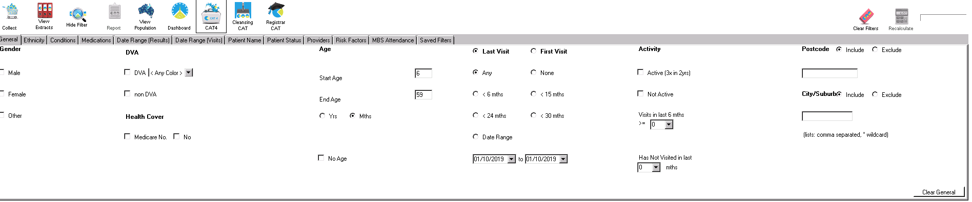

In the report section, click the Immunisations tab which opens to influenza. Click on the graph to select sections of ‘Previous Year’, ‘Prior to Previous Year’ and ‘Nothing Recorded’. 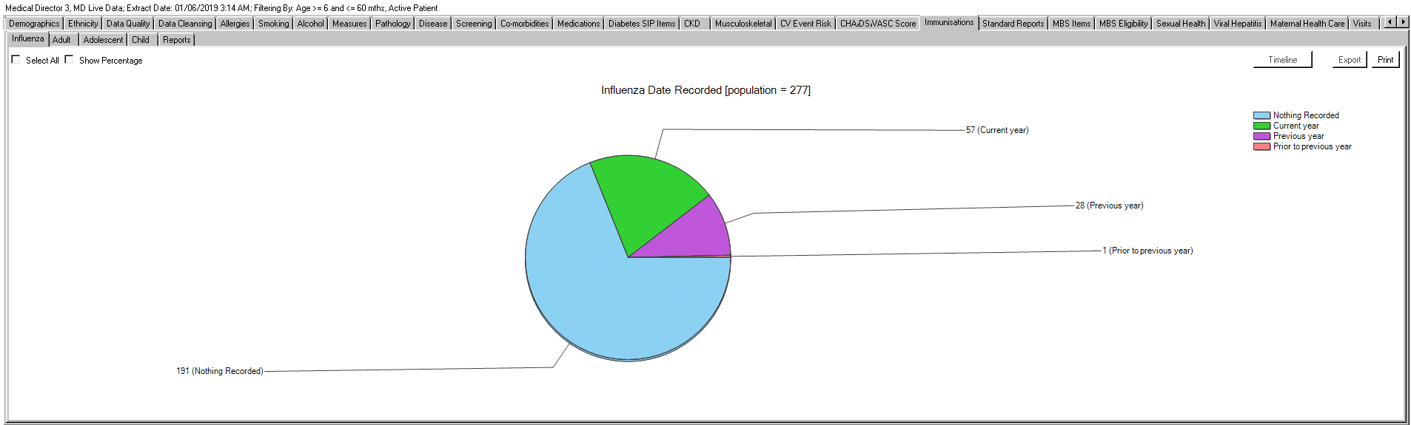

Select Report at the top of screen. A list will generate of patients with missing/overdue influenza vaccinations
