Recipe – Influenza immunisation for patients aged 5 to 64 (excluding patients with chronic conditions)
Under the ‘General’ tab enter the following filters:
- Active Patients’ (3x <2 years)
- Start Age 5, End Age 64
- Conditions – click ‘No’ for diabetes, respiratory, cardiovascular, musculoskeletal, renal impairment
- Date Range (Results) < 15 months

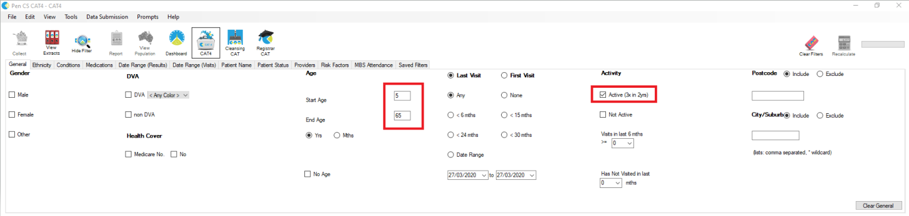
5 Thank you for your enquiry.
Gold Coast Primary Health Network (GCPHN) has been provided a limited allocation of surgical masks from the Commonwealth Government stocks for distribution to pharmacies.
These masks are specifically for use by pharmacists and their staff, and where required, to assist in infection control for people with suspected cases of COVID-19. They are not to be on sold.
The Australian Government Department of Health has provided a Fact Sheet outlining the use of surgical masks.
Please note we have not been provided with additional PPE resources such as gowns and goggles and/or hand sanitiser and hand wash and we have been advised that pharmacies should contact their usual supplier for these items.
If you require additional supplies in the future, and are unable to source them from your usual PPE suppliers, please contact us.
I can organise 1 box to be delivered within the next 1-2 business days.

64 Thank you for your enquiry.
Gold Coast Primary Health Network (GCPHN) has been provided a limited allocation of surgical masks from the Commonwealth Government stocks for distribution to pharmacies.
These masks are specifically for use by pharmacists and their staff, and where required, to assist in infection control for people with suspected cases of COVID-19. They are not to be on sold.
The Australian Government Department of Health has provided a Fact Sheet outlining the use of surgical masks.
Please note we have not been provided with additional PPE resources such as gowns and goggles and/or hand sanitiser and hand wash and we have been advised that pharmacies should contact their usual supplier for these items.
If you require additional supplies in the future, and are unable to source them from your usual PPE suppliers, please contact us.
I can organise 1 box to be delivered within the next 1-2 business days.

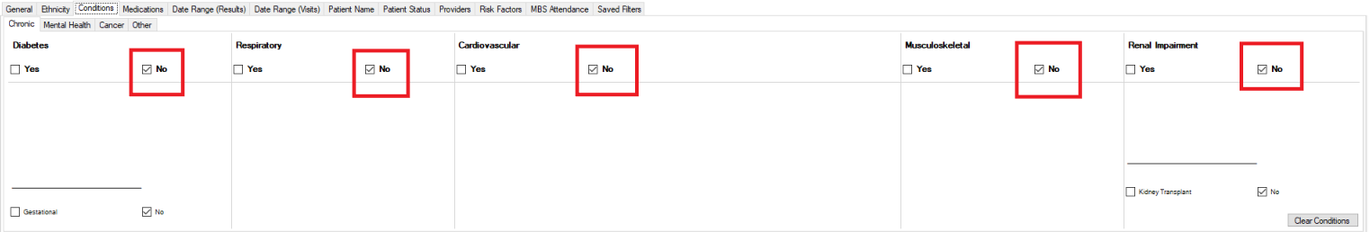

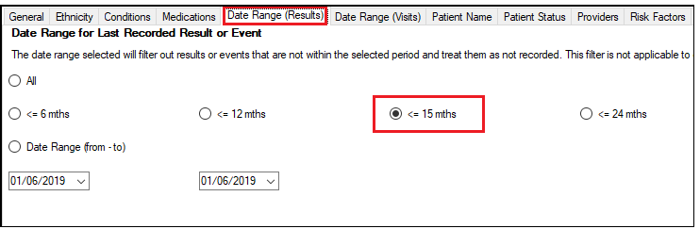

Click Recalculate

Select the "Immunisation/Influenza" tab
- This report will show you the Immunisation status of your selected patient group and will allow you to measure improvement over time by comparing your reports. The percentage of patients with 'Nothing Recorded' are those patients without an immunisation in the last 15 months
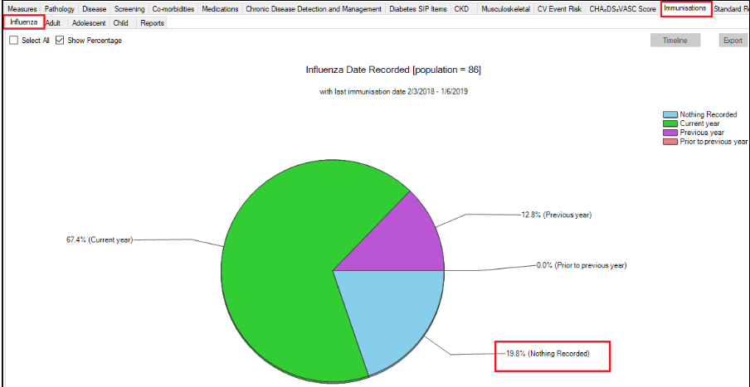

The immunisation report is designed to show patients who have received the current vaccine for the calendar year, so the 15 month criteria for this measure will show patients who have received last year’s vaccine if it was within 15 months of the data extract date. Patients appearing in the ‘previous year’ category might still benefit from a vaccine this year!

To Export Patient List to Microsoft Excel:

1. Click on the “Export Icon” at the top of the Patient Reidentification window.

2. Click on “Excel”

3. Choose a file name and a location to save to (eg. Create a folder C:/ClinicalAudit/CAT Patient FollowUp)

4. Click “Save”

