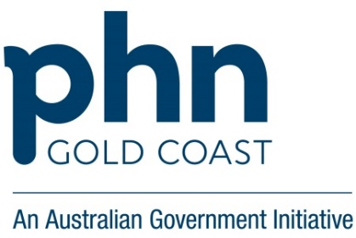

Continuous Quality Improvement (CQI)

Children and Young People in care with no health and developmental assessment completed

CQI steps |  | Ask-Do-Describe
Data report 1 - baseline | First CQI meeting | Why do we want to change?
 |  | - Gap | Low rates of annual health and development assessments completed on children and young people in care. These children have a higher risk of health issues.
 |  | - Benefits | Improved Health outcomes, meet PIP QI requirements, reduce risk, increase efficiency, promote healthy lifestyle, early identification of health care needs to facilitate proactive care.
 |  | - Evidence | Refer to Health assessment pathway for children and young people in care or National Clinical Assessment Framework for children and young people in out-of-home care.
 |  | What do we want to change?
 |  | - Topic | Completion of an annual health and developmental assessment for children and young people in care.
 |  | - Scope | Children and young people currently in care.
 |  | How much do we want to change?
 |  | - Baseline (%) | Current % of patients in care with a completed health and developmental assessment.
 |  | - Sample (number) | Number of eligible patients.
 |  | - Target | Increase the number of completed health and developmental assessments by 50%.
 |  | - Preparedness | Practice team involved in identifying this as an activity
 |  | Who are involved in the change?
 |  | - Leads  Contributors | (include any relevant team members)  Practice Manager, CQI Lead, Practice Nurse, Receptionist
 |  | - External | Consider support required here from external companies.
 |  | When are we making the change?
 |  | - Deadlines | Start date dd/mm/yyyy End Date dd/mm/yyyy  Consider your sample size and how long it will take to invite/complete.
 |  | How are we going to change?
 |  | - Potential solutions | - Update practice new patient registration form to include living arrangements, carer and child safety contact details. Ensure this information is included in the patient’s records.  - Identify children and young people who are currently living in care and review if they have had a health assessment completed.  - Upload health assessment templates into practice clinical software package.  - Ensure all relevant team members are aware of how to access health and development assessment templates and understand their role within the assessment.  - Ensure all relevant team members are aware of children in care health pathway.
 |  | - Select
- Implementation |  | - Implement
 |  | - Record, share
Data Report 2  Comparison | Final CQI meeting | How much did we change?
 |  | - Performance
 |  | - Worthwhile
 |  | - Learn
 |  | What next?
 |  | - Sustain
 |  | - Monitor

See Guide to Completing the CQI Template for more information https://gcphn.org.au/wp-content/uploads/2019/10/Guide-to-completing-the-CQI-template.pdf

