### **Continuous Quality Improvement (CQI) – Children and Young People in Care *How To Resource* for practice software**

### **Best Practice**

### Recording information in Best Practice

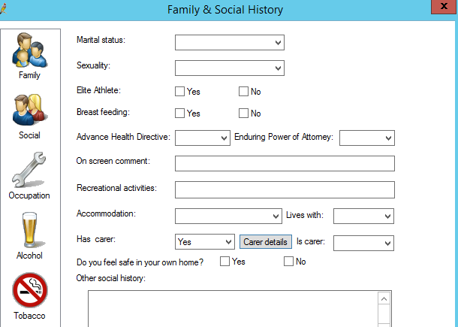To record child in care and carer details:

1. Open patient’s file.
2. Open the family & social history screen.
3. Next to **On screen comment:** type **Out of Home Care.**
4. To enter carer details, select **yes** to has carer.
5. Click on the **Carer details** button.
6. Enter carer details and select **Save**.

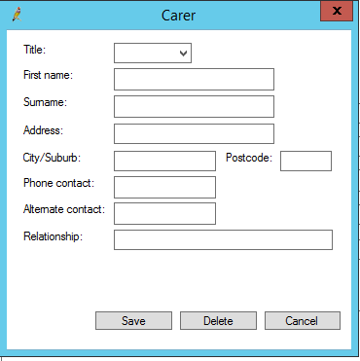

## 

## Entering diagnosis &/or reason for visit in Best Practice

Best Practice users are able to enter in the diagnosis and reason for visit fields, **Out-of-home care.** To do this:

1. Open patient’s file.
2. Under progress notes, select **Reason**.
3. In the search field, type **out-of-home care**.
4. You can choose to add this to **Past History**, include if it is **Active** or **Inactive**.
5. Click **Save** to record.

## 

## Searching patient database in Best Practice

To conduct a search of patients with a condition marked in their past history, in Best Practice:

1. From the Best Practice screen, select **Utilities** & **Search.**

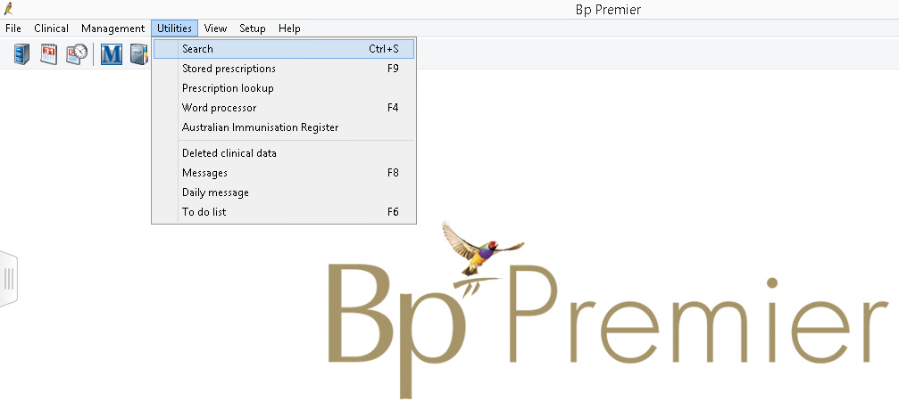

1. 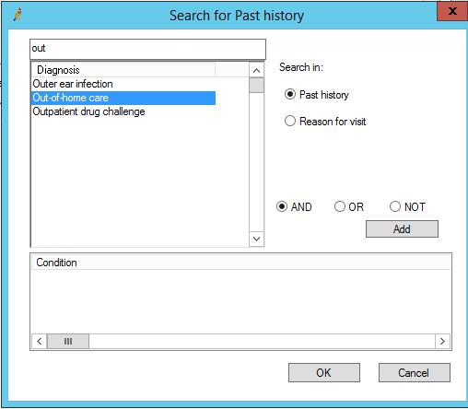From the **Setup search** menu, select **Conditions.**
2. A search for past history screen will appear.
3. In the **Diagnosis** box, enter the diagnosis you want to search for and select **Past history** or **Reason for visit.**
4. Select **Add.**
5. Select **OK.**
6. Select **Run Query** and your list of patients with the specific diagnosis will appear.

### Setting up appointment reminder in Best Practice

1. Open the patient file.
2. Select **Edit patient**.
3. Type reminder in the **Appointment notes** section.
4. **Save** to complete.
5. Every time this patient is being booked an appointment, the prompt will appear.

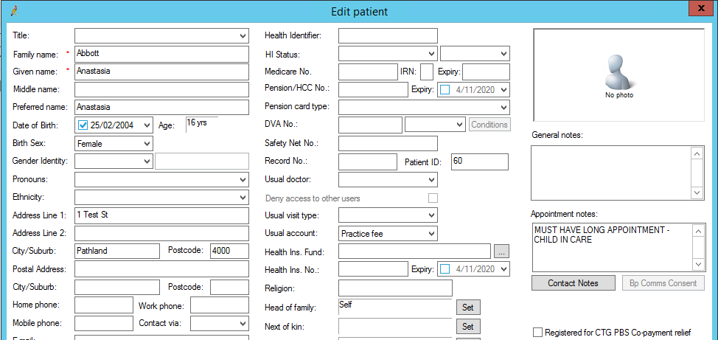

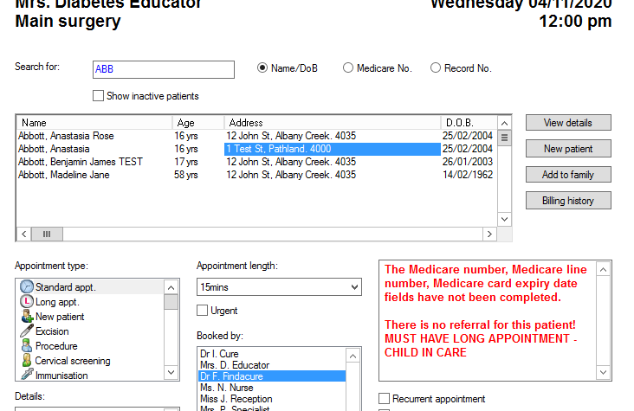

### **Medical Director**

### Recording information in Medical Director

To record Out of Home Care in Warnings:

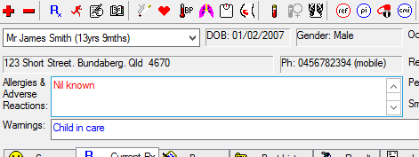

Out of Home Care

1. Open patient’s file.
2. Double click on the white box next to **Warnings**.
3. Type **Out of Home Care**.
4. Select **save**.

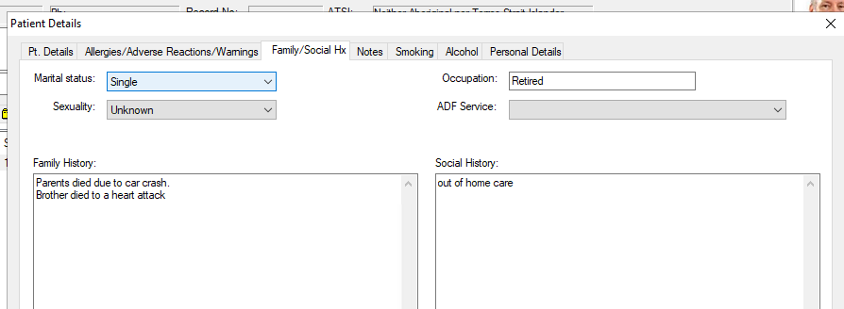To record Out of Home Care in Social History:

1. Open patient’s file.
2. Open Family/social Hx.
3. Type **Out of Home Care**.
4. Select **save**.

To record carer details:

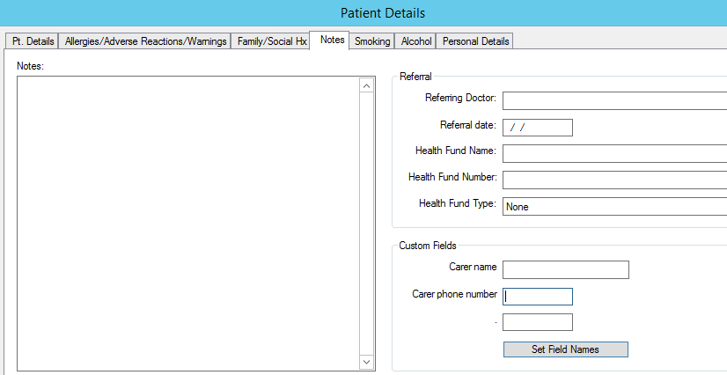If your practice does not currently use the custom fields in the patient details screen, you can edit these to include carer details. To do this:

1. Open patient’s file.
2. Open the **patient details** screen.
3. Select **notes**.
4. Under the **Custom Fields**, click on **Set Field Names**.
5. You are then able to customise 3 fields to suit the needs of your practice. In the example below, we have included **Carer name** & **Carer phone number**.
6. Click **Save** to close.

### Setting up appointment reminder in Pracsoft

1. 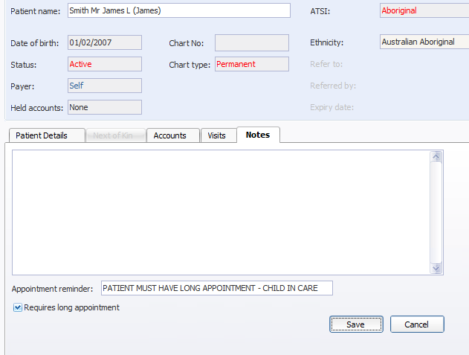Open the patient file.
2. Select **Notes**.
3. Type reminder in the **Appointment reminder** section.
4. Select **Requires long appointment.**
5. **Save** to complete.
6. Every time this patient is being booked an appointment, these prompts will appear.