Service Classifications Primary Mental Health Services

DOCUMENT CONTROL
Managed by:  Program Coordinator – Service Design, Performance Improvement and Special Projects. | Approved by:  Executive Director of Commissioning (Programs) | Version:  1.2
Next review date:  18 May 2026 | Date approved:  18 May 2023 | Status:  Final

REVISION RECORD
Date | Version | Revision Description
07/04/2022 | 1.1 | Reviewed – no changes required. Content up to date.
18/05/2023 | 1.2 | Reviewed – added website details National Mental Health Service Planning Framework - AIHW

Service Planning
Background
The National Mental Health Service Planning Framework (NMHSPF) is an evidence-based framework designed to plan, coordinate and resource mental health services to meet population needs. The NMHSPF is an opportunity to provide a nationally consistent approach to mental health service planning and delivery. This Framework is a comprehensive model of the mental health service types and resources required to meet the needs of a given population, across the full spectrum of need from community focused programs to promote mental health and prevent the onset of mental health problems, to the most intensive services for people with severe disorders.
At a local level, in 2019 the Joint Regional Plan Steering Committee endorsed the use of the NMHSPF to describe the local service system. GCPHN is using the NMHSPF to:
- Align language and description of services with an aim to build consistency and facilitate discussion on how we describe the service system the exact nature of what we are purchasing and
- Understand how services align to and fit into broader framework which supports GCPHN to prioritise based on gaps and potential duplications in services and systems
- Improve quality of service delivery by ensuring people are receiving the right type of treatment for need

The intended purpose of this document is to support GCPHN to align language and descriptions of services.
Limitations
Complementing the NMHSPF is the NMHSPF Planning Support Tool (PST) which provides estimates of prevalence and numbers of people requiring different types of treatment or care, the services required, and the workforce needed to deliver them. The NMHSPF PST provides an idealised description of what a service system could be, based on nationalised statistics. The full value and use of this tool is a number of years off and there are a range of limitations to use of the tool, including
- Limited number of people trained
- Restricted access to tool and the outputs of the tool
- Difficult to have a clear picture of current service delivery across primary and community care with numerous independent providers

Within GCPHN, accountability for use of the NMHSPF PST sits with the Programs Manager-Planning & Stakeholder Engagement.
Mental Health Services (Taxonomy) and Workforce Categories

Figure 1. The National Mental Health Service Planning Framework Taxonomy (Classification) for Mental Health Services
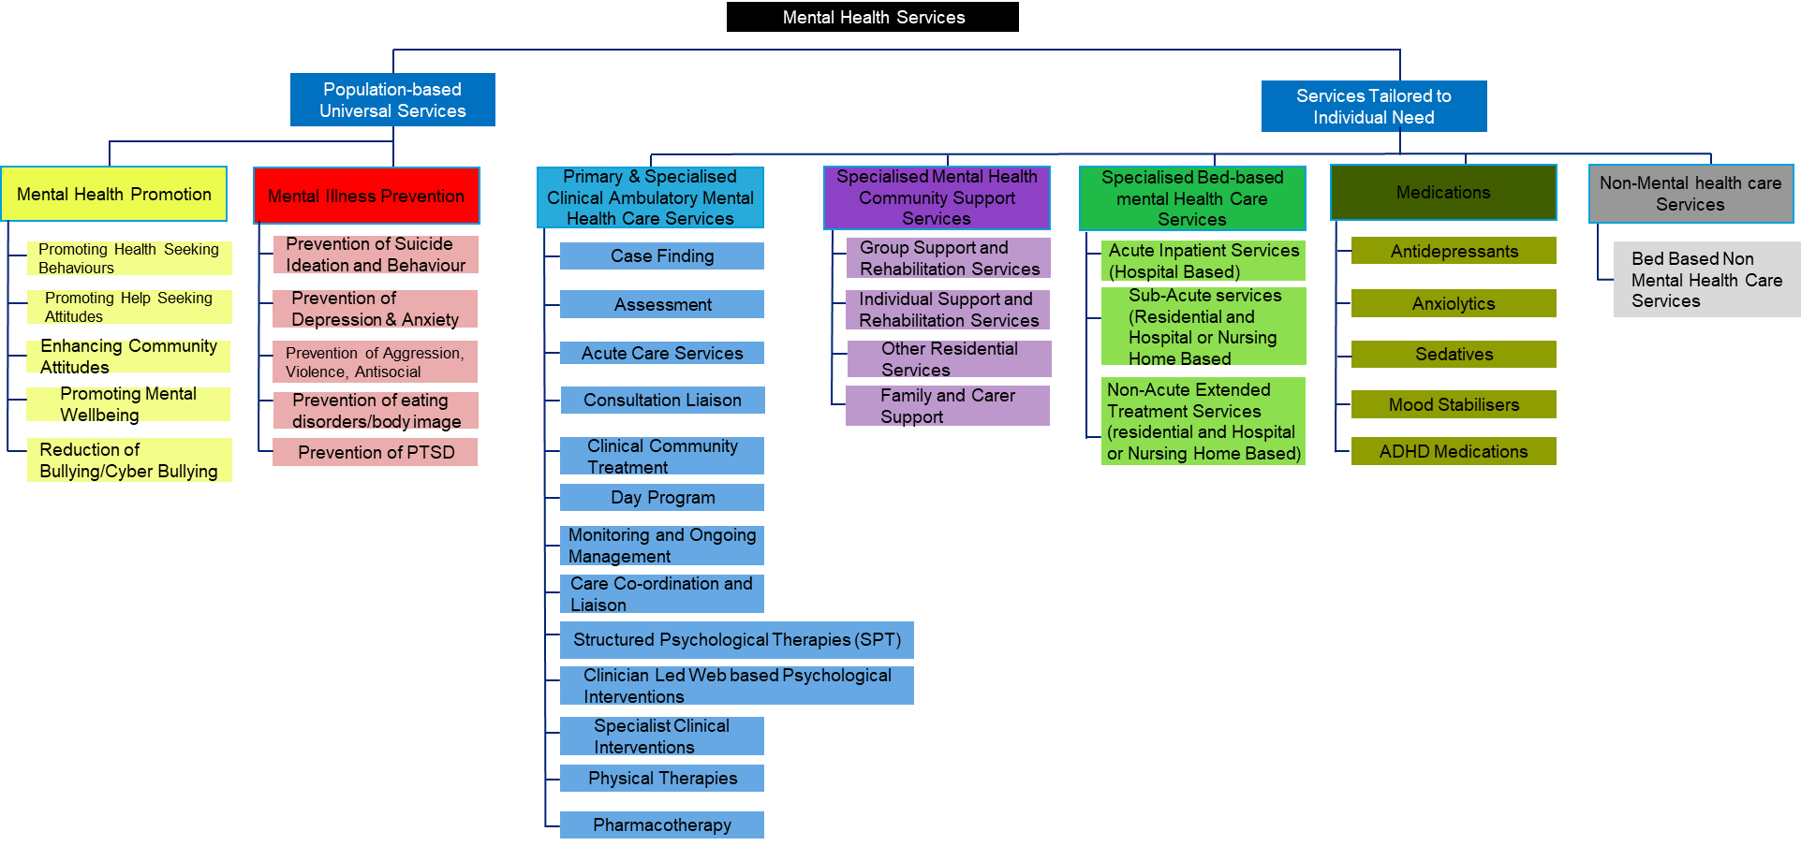
The NMHSPF taxonomy, or classifications for mental health describe the full range of services required that are ideally required for a comprehensive mental health system across the region. GCPHN does not fund the full suite of Services in the taxonomy with its current funding and investment aligned predominately in the two Service Streams Primary & Community Clinical Ambulatory Mental Health Services and Specialist Mental health Community Support Services (previously described as Psychosocial Services.). Queensland Government and the Gold Coast Hospital and Health Service predominately provide funding and service delivery across the Service Streams aligned with “Services Tailored to Individual Needs”.
Workforce Categories
Mental health services are delivered by a range of health and social care professionals across the public. private and non-government sectors. Using the NMHSPF workforce categories as a guide, the local workforce can be classified as outlined below in Table 1.
Table 1: Workforce categories
Workforce Category | Staff Types
Peer Support Worker | Consumer /Lived experience Peer Worker  Carer Peer/Lived Experience Worker
Vocationally Qualified  (Cert III or IV) | MH Worker  Enrolled Nurse  Vocationally Qualified  Support Workers
Tertiary Qualified | Nurse Practitioner  Clinical Nurse  Social Worker  Physiotherapy  Psychologist  Other
Medical | GP  Psychiatrist  Registrar  Specialist other  Junior Doctor

SERVICE CLASSIFICATIONS
The purpose of these service classifications is to serve as a guide and prompt initial discussions with funded providers on the types of services they are providing and how they align to the taxonomy. Due to the scope of PHN funding, these service specifications cover the service category and element level of the following streams of the taxonomy: Mental Health Promotion, Mental Illness Prevention, Primary and Specialised Clinical Ambulatory Mental Health Care Services, Specialised Mental Health Community Support Services. While GCPHN primarily funds Primary and Community Clinical Ambulatory Mental Health Services and Specialist Mental health Community Support Services), GCPHN recognises that funded providers may provide additional services as part of their broader service offering through other funding sources.
The service classifications below are based on the following taxonomy.
Figure 2: Overview of the NMHSPF Taxonomy Classification) Structure
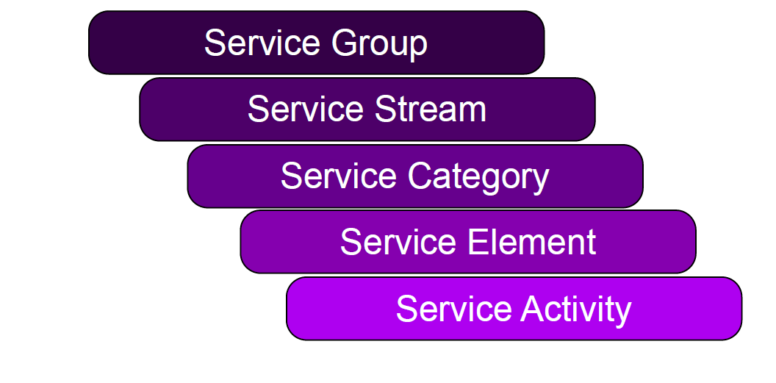
Flowing from the taxonomy are descriptions of service elements and their activities to ensure clarity on the scope and function of each item in the classification. Example below
Classification Structure | Example
Service Group | Services tailored to Individuals
Service Stream | Specialist Mental Health Community Support Services
Service Category | Individual Support and Rehabilitation Services
Service Element | Individual Support and Rehabilitation
Service Activity | Individual Support and Rehabilitation linked to accessing housing and maintaining secure housing including practical skills for maintaining a home and Living

The service classifications below primarily align with the NMHSPF Service Category or Service Element level and do not drop to Service Activity at this stage. In some instances, remaining at the Service Category level may be most appropriate. For services within the primary scope of GCPHN funding, Service Element level descriptors may be most appropriate.
This document will evolve over time to reflect the scope of GCPHN work. In the meantime, f there is a need for descriptors for services not listed below, refer to the NMHSPF.
Service Group: Population Based Universal Services
Service Stream: Mental Health Promotion
Service Category Descriptions
Promoting Health Seeking behaviours | Interventions designed to affect help seeking behaviours for mental illness using mass promotion through media campaigns, websites, books, brochures, videos, TV ads, billboards, personalities.
Promoting Help Seeking Attitudes | Includes mass promotion campaigns using a range of media formats and structured psycho education either online or in person to affect help seeking attitudes for mental illness.
Enhancing Community Attitudes and Stigma Reduction | Interventions designed to challenge stigma and impact on community attitudes towards mental health, this includes:  - interactions with people with a history of mental illness (usually accompanied by education)  - intensive education interventions using a range of methods  - mass promotion/advertising campaigns  - Enhancing mental health first-aid behaviours
Promoting Mental Wellbeing | Includes social and emotional learning and positive psychology elements. Social and emotional learning interventions are targeted towards adolescents and are connected to schools with explicit goals and focus on active learning and skills development  Positive psychology interventions are for adults with any mental disorder delivered for more than 4 weeks but less than 12 weeks. Activities may include mindfulness, positive writing, hope therapy, positive reminiscence, gratitude, happiness programs, wellbeing therapy, positive psychotherapy, CBT
Social and Emotional Learning (service element) | Classroom-based interventions, interventions for parents, whole of school policy development with explicit goals and focus on active learning and skills development
Positive Psychology (service element) | Mindfulness, positive writing, hope therapy, positive reminiscence, gratitude, happiness programs, wellbeing therapy, positive psychotherapy, CBT
Reduction of Bullying/Cyber Bullying | Using a whole of school approach to reduce bullying through training of school staff and parents, videos, rules, and counselling.

Service Stream: Mental Illness Prevention
Service Categories | Description
Prevention of Suicide, Suicide Ideation and Behaviour | Interventions to prevent suicide, suicide ideation and behaviour including:  - Restriction to means  - Training for non-medical community gatekeepers (people with greater exposure than general public to high-risk groups and greater ability to identify, intervene and refer)  - Media guidelines and responsible reporting of suicide  - Crisis intervention telephone and internet helplines  - Web based programs
Prevention of Depression & Anxiety | Interventions to prevent depression of anxiety and depression including:  - CBT for school-based anxiety and depression (5-17 years)  - Parent training and family strengthening for pre-school  - Individual, group and web-based CBT for adults to reduce depression risk and symptoms  School-based CBT for anxiety and depression
Prevention of Aggression, Violence, Antisocial, Conduct Disorder, Externalising | Interventions designed to prevent aggression, violence, antisocial, conduct disorder and externalising. This includes:  - Behavioural interventions with ‘parents’ including training for parents to better manage the child and family as well as Multidimensional Treatment Foster Care (MTFC)  - Universal School-based interventions including education about antisocial behaviour, emotional self-awareness, emotional control, self-esteem, conflict resolution and social skills  school-based interventions for children identified as having a disruptive behaviour or as having externalising behaviour problems.
Prevention of eating disorders/body image | A range of universal and targeted school, university or community-based activities to prevent eating disorders and intervene early.
Prevention of PTSD | - Trauma focussed CBT, which includes exposure and/or cognitive therapy

Service Group – Services Tailored to individual Needs
Service Stream: Primary and Specialist Clinical Ambulatory Mental Health Care Services
Service Category

Case finding | GP or practice nurse conducting screening to detect the presence of a mental health illness in individuals presenting to primary care with risk factors for mental illness. Lasts an average of 15 minutes.
Service Category Assessment | A determination of a person‘s mental health status and need for mental health services, made by a suitably trained mental health professional or mental health team (which may consist of a psychiatrist, psychologist, mental health nurse and/or allied health professional), based on the collection and evaluation of data obtained through interview and observation, of a person‘s mental history and presenting problem(s). The assessment may include consultation with the person‘s family and concludes with formation of problems/issues, documentation of a preliminary diagnosis or diagnosis, and a written treatment plan supported by the assessment and interview data
Service Elements
Brief Mental Health Assessment (service element) | Assessment up to 30 minutes (averaging 15 minutes) that involves the gathering, evaluation and recording of information by suitably trained health or mental health professional relative to the person‘s problem(s), strengths, functional status or situation and must include (but is not limited to) at least two of the following assessment components:  • Mental status assessment • Mental health history assessment • Triage/emergency assessment • Risk assessment • Medication assessment • Social assessment Environmental assessment • Assessment summary and clinical formulation • Review of care plan Developmental or observational assessment • Functional assessment • Cognitive assessment Psychological assessment • Rehabilitation assessment • Administer an outcome measurement tool
Comprehensive Mental Health Assessment | Assessment up to 60 minutes (averaging 45 minutes) that involves the gathering, evaluation and recording of information by suitably trained health or mental health professional relative to the person‘s problem(s), strengths, functional status or situation and must include (but is not limited to) at least four of the following assessment components:  - Mental status assessment; • Mental health history assessment; • Risk assessment; • Medication assessment • Social assessment • Environmental assessment • Assessment summary and clinical formulation • Development of a further care plan (even if the plan includes provision of no further services); • Review of care plan • Developmental or observational assessment • Functional assessment • Cognitive assessment • Psychological assessment • Rehabilitation assessment • Administer an outcome measurement tool • Assessment summary and clinical formulation • Development and Review of a Recovery Plan.
Brief Physical Assessment | Up to 30 minutes assessment (average 15 mins) that involves collection and assessment of information relating to physical health. A physical assessment is usually conducted as part of the general mental health assessment to determine appropriate interventions. This is a targeted assessment that includes at least 1 of the components of a comprehensive physical assessment. This may include but is not limited to:  • Monitoring of medication side effects • Preventative health review • Monitor metabolic syndrome risk factors • Monitor abnormal involuntary movements • Monitor basic physical observations (pulse, BP, temperature, respiratory rate) Monitoring of medication side effects • Preventative health review • Monitor metabolic syndrome risk factors • Monitor abnormal involuntary movements • Monitor basic physical observations (pulse, BP, temperature, respiratory rate) • Physical examination o Cardiovascular Respiratory o Gastrointestinal o Neurological (brief and comprehensive) o Other
Comprehensive Physical Assessment (service element) | Up to 60 minutes assessment (average 45 minutes) that involves the collection and assessment of information relating to the physical state of a person with a mental health condition. This is usually conducted with the general mental health assessment because it is important to assess both the physical and mental health status of the person to determine appropriate interventions, especially those involving medications.  Includes:  • information collection, including taking a patient history and undertaking examinations and investigations as clinically required;  • making an overall assessment of the patient’s health, including the patient’s readiness to make lifestyle changes;  • initiating interventions and referrals as clinically indicated;  • providing advice and information about lifestyle modification programs to the patient including strategies to achieve lifestyle and behaviour changes;  • keeping a record of the health assessment, and offering the patient a written report about the health assessment, with recommendations about matters covered by the health assessment; and  • offering the patient’s family, friends, support people and carers (if any, and if the medical practitioner considers it appropriate and the patient agrees) a copy of the report or extracts of the report relevant to the carer.
Assessment- Other | Up to 60 minutes assessment that is not a mental health or physical assessment. This could be an assessment for exercise based or occupational therapy. This involves a mental health professional undertaking an assessment of the impact of mental illness on a person’s ability to fulfil their roles and responsibilities. This may have a focus on activities such as employment, parenting or other specific abilities.
Service Category Clinical Community Treatment Services
Service Element
Community Clinical Treatment Team 0 - 17  Community Clinical Treatment Team Adult 18 – 65 years  Community Clinical Treatment Team Older Adult 65 +years | Clinical Community Team (0 - 12 years)  Clinical Community Team (12 – 25 years)  Clinical Community Team Adult (18 -64 years)  Clinical Community Team (65 plus)  ClinicalCommunity Treatment Services (CCTS) are deliveredby multidisciplinary teams who provide ongoing recovery oriented assessment and assertive treatment and care, aimed at improving the quality of life for persons with complex mental health needs requiring intensive intervention in a community or residential setting.  The key functions of Clinical Community Treatment Services are to:  • provide intensive, developmentally appropriate, specialist mental health interventions and ongoing assessment for those persons who require the higher intensity (level of contact, range of interventions/services) treatment, rehabilitation and support to recover from mental illness  • minimise the impact of mental illness on people, their family, friends, support people and carers, who are living in the community  • facilitate access to a broad range of clinical and non-clinical services to enable people to establish, re-establish or reclaim a meaningful life  • work with the person and their network to develop their sense of self efficacy, personal support systems and live independently to participate fully in their community.  • ensure engagement with primary care and other specialist service providers to enable access to early intervention and timely treatment.  Age specific adult (18-64) Clinical Community Treatment Services are provided on an extended hours basis and delivered via mobile outreach. Child and Adolescent (0-17) and Older Persons (65+) Clinical Community Treatment Services are primarily provided in business hours and may be provided over extended hours to meet particular needs. All age services have an early intervention and prevention focus to assist people to manage crisis situations and reduce the need for inpatient care or the length of an inpatient stay. The approach places a strong emphasis on psycho education, vocational rehabilitation, and consultation, collaboration and co-ordination with other key services and health care providers.  Further information: Refer to page 118 National Mental Health Service Performance Framework
Service Category – Monitoring and Ongoing Management
 | Involves the ongoing systematic collection, analysis, interpretation of information for the ongoing management of a person‘s health status and/or ongoing need for specialist mental health services. This is performed by specialist trained mental health professionals. (E.g. psychiatrists, psychologists, mental health nurses and/or allied health professionals) Monitoring involves the collection and evaluation of data obtained through interview and observation, including taking a comprehensive history and exploration of presenting problem(s). Monitoring and ongoing assessment will include consultation with the person‘s family and concludes with a formulation of problems/issues, a preliminary diagnosis or diagnosis, and an updated treatment.
Service Element
Centre-based Monitoring and Ongoing Management (service element) | The nature of the centre-based support will depend on the person’s needs. Services provided by clinicians will include:  o Mental health status monitoring;  o Risk assessment;  o Risk management plan;  o Physical health review;  o Family, friends, support people and carers need assessment.  o Social and environmental assessment;  o Individualised Care Plan and Review.
Home-based monitoring and Ongoing management (service element) | Involves the ongoing systematic collection, analysis, interpretation of information for the ongoing management of a person ‘s health status and/or ongoing need for specialist mental health services. This is performed by specialist trained mental health professionals. (E.g. psychiatrists, psychologists, mental health nurses and/or allied health professionals) Monitoring involves the collection and evaluation of data obtained through interview and observation, including taking a comprehensive history and exploration of presenting problem(s). Monitoring and ongoing assessment will include consultation with the person ‘s family and concludes with a formulation of problems/issues, a preliminary diagnosis or diagnosis, and an updated treatment.  The nature of the home/outreach support will depend on the person’s needs. Services provided by clinicians will include:  o Mental health status monitoring;  o Risk assessment;  o Risk management plan;  o Physical health review;  o Family, friends, support people and carers need assessment.  o Social and environmental assessment.  o Individualised Care Plan and Review.
General Physical Health Monitoring and Ongoing Management (service element) | Involves the ongoing systematic collection, analysis, interpretation of information for the ongoing management of a person ‘s health status and/or ongoing need for specialist mental health services. This is performed by specialist trained mental health professionals. (E.g. psychiatrists, psychologists, mental health nurses and/or allied health professionals) Monitoring involves the collection and evaluation of data obtained through interview and observation, including taking a comprehensive history and exploration of presenting problem(s). Monitoring and ongoing assessment will include consultation with the person ‘s family and concludes with a formulation of problems/issues, a preliminary diagnosis or diagnosis, and an updated treatment.  Monitoring required as part of good mental health treatment, including metabolic screening (Body Mass Index (BMI), waist circumference, weight, BP, blood tests etc.) and screening to comply with treatment guidelines (e.g. mandatory monitoring criteria - clozapine).
Service Category Care coordination and Liaison
Involves working in partnership and liaison with primary care providers, acute health and emergency services, rehabilitation and support services, family, friends, support people and carers and other agencies that occur outside of the clinical encounter. Care Coordination and Liaison includes:
• Person centred interagency planning meeting (Case Conferences)
• Liaison and/or consultation with family, friends, support people and carers
• Liaison with other services/agencies including schools – verbal and written
• Transition Planning / Handover / Referral / Discharge Planning
• Multi-Disciplinary Team Reviews
• Medical records if outside of the clinical encounter.

Service Category Structured Psychological Therapies
A structured interaction between a participant and a qualified mental health professional(s) using a recognised, psychological method, for example, cognitive behavioural techniques, family therapy or psycho education counselling. These are recognised, structured or published techniques for the treatment of mental and emotional illnesses. Structured psychological interventions are designed to alleviate psychological distress or emotional disturbance, change maladaptive behaviour and foster mental health. The interventions embrace the following three approaches: Psychosocial therapy, Education and/or Counselling. Structured psychological therapies can be delivered on either an individual or group basis, typically in an office or community setting.
Structured Psychological Therapies include but are not limited to:

• Cognitive Behaviour Therapy  • Dialectical Behaviour therapy (DBT).  • Acceptance and Commitment Therapy (ACT)  • Insight-oriented therapy  • Psycho education  • Cognitive Skills Training/Remediation  • Couple therapy | Supportive psychotherapy  • Play therapy  • Interpersonal psychotherapy  • Narrative therapy  • Family, friends, support people and carers -focussed therapy and interventions
Techniques often used within cognitive and/or behavioural therapies include:
Cognitive restructuring  • Cognitive remediation  • Desensitisation (graded exposure or exposure therapy)  • Relapse-prevention  • Relaxation  • Response-prevention | • Rational emotive therapy  • Role play/rehearsal  • Structured problem solving  • Treatment adherence

Service Elements
SPT Low Intensity – Individual | A structured brief intervention between the consumer and a vocationally qualified worker. The intervention is easy-to-use, and delivered in accessible and non-stigmatising ways. It includes an assessment; evidence based cognitive behavioural therapy (CBT); measurement of clinical outcomes at each session; and a clinical risk management system that enables people requiring higher intensity services to be promptly identified and stepped up to appropriate services. Providers delivering these services have undergone a specific training program to become a low intensity worker and receive frequent supervision from a tertiary qualified professional with a mental health background (e.g. mental health nurse, psychologist, social worker). Psychological interventions are designed to alleviate psychological distress or emotional disturbance, change maladaptive behaviour and foster mental wellbeing. It may be delivered face to face or via telephone; video conferencing and/or Skype (as a substitute for face to face consultation).
SPT Brief Intervention – Individual | A structured interaction, less than 15 minutes, between the person and a qualified mental health professional using a recognised, psychological method - e.g., CBT, family therapy or psycho-education counselling. Psychological interventions are designed to alleviate psychological distress or emotional disturbance, change maladaptive behaviour and foster mental wellbeing. It may be face to face; telephone; video conferencing and/or Skype (as a substitute for face to face consultation).
SPT Brief Intervention – Family | A structured interaction, less than 15 minutes, between the person’s family and a qualified mental health professional using a recognised, psychological method - e.g., CBT, family therapy or psycho-education counselling. Psychological interventions are designed to alleviate psychological distress or emotional disturbance, change maladaptive behaviour and foster mental health. Family interventions focus on building personal capacity, resilience, coping skills and mutual support for family, friends, support people and carers. Includes services such as access to education and information, individual advocacy, intensive support to assist in navigating the mental wellbeing and community care systems. These may be face to face; telephone; video conferencing and/or Skype, dyadic work
SPT Extended Intervention – Individual | A structured interaction, lasting 45 minutes, between the person and a qualified mental health professional using a recognised, psychological method - e.g., CBT, family therapy or psycho-education counselling. Psychological interventions are designed to alleviate psychological distress or emotional disturbance, change maladaptive behaviour and foster mental wellbeing. These may be face to face; telephone; video conferencing and/or Skype.
SPT Extended Intervention – Family | A structured interaction, lasting 45 minutes, between the person’s family and a qualified mental health professional using a recognised, psychological method - e.g., CBT, family therapy or psycho-education counselling. The scope of interventions is limited to family, friends, support people and carers. It should be noted that in this context, family, friends, support people and carers includes people who have a significant emotional connection to the person, such as friends and partners support person, and those who have a formal role as the person‘s carer. These may be face to face; telephone; video conferencing and/or Skype.
Service Category Specialist Clinical Interventions- other
 | Interventions carried out by specialist trained mental health clinicians during a service contact to improve, maintain or assess the health of a person that are not defined elsewhere. If not therapeutic or diagnostic, an intervention will nevertheless contribute materially to the improvement of a client’s health, alter the course of a health condition or promote wellness. Interventions include invasive and non-invasive procedures, cognitive interventions and other interventions (including psychosocial interventions)
Service Category Physical Therapies
Other Evidence-based Physical Therapies (service element) | Other evidence-based activities such as:  - light therapy as a treatment for Seasonal Affective Disorder  - exercise for older adults
Service Category Pharmacotherapy
Service Element
Pharmocotherapy Prescription | The clinical assessment and subsequent judgement that pharmacotherapy is appropriate and indicated for the person. It typically will also involve the prescribing of an appropriate pharmacological agent and may include the preparation and administration of oral or depot intramuscular injection (IMI). As well as details of the medication prescribed, the administration route and whether the prescription is new or a repeat, is collected.
Pharmocotherapy Review | Review of a person’s current medication regime to determine appropriateness of the regime and an assessment of the person’s ability to manage medication safely.

Service Stream Specialised Mental Health Community Support Services
Service Category Group Support and Rehabilitation Services
 | Services targeted for people with moderate to severe mental illness that aim to improve the quality of life and psychosocial functioning of people using mental health services. Included in this element are psychosocial group programs, recovery-oriented groups (eg. Exercise/Sport/Recreational, Community Access, life skills, health management, volunteering, opportunity programs, individual/ family/ friend/ carer education, arts based therapeutic services, leadership programs, relaxation/mindfulness and groups for specialised populations). Groups may be centre based (eg day program) or Sessional (eg 2hrs per week) in nature and may or may not be structured, time limited or ongoing.
Service Element
Group Support and Rehabilitation (service element) | Group based services targeted for people with moderate to severe mental illness that aim to improve the quality of life and psychosocial functioning of people using mental health services. Included in this element are psychosocial group programs, recovery-oriented groups (eg. Exercise/Sport/Recreational, Community Access, life skills, health management, volunteering, opportunity programs, individual/ family/ friend/ carer education, arts based therapeutic services, leadership programs, relaxation/mindfulness and groups for specialised populations). Groups may be centre based (eg day program) or Sessional (eg 2hrs per week) in nature and may or may not be structured, time limited or ongoing.
Group Based Peer Work (service element) | Group based services that share a common interest and are led and self-managed by peer workers. Includes services that aim to empower and support the individual, family, friends or support person by working through group processes and sharing life experiences with people who have similar experiences and to help develop support networks for crisis situations. Have a mental health promotion and prevention and psychological education function through ‘wellbeing’ benefit.
Service Category Individual Support and Rehabilitation Services
Personalised support and psychosocial rehabilitation provided on an individual basis. This may include functions such as:
- assessment of priorities, strengths values and needs
- goal setting
- skills development, coaching, counselling, co-ordination of services, building personal and community resources
- support to access community transport, domestic support services, vocational, recreational and health management activities.

Can occur in a wide variety of settings e.g. in the person’s home, in the community, in residential facilities or inpatient facilities.

Service Element
Individual Support and Rehabilitation (service element) | Personalised support and psychosocial rehabilitation provided on an individual basis. This may include functions such as:  - assessment of priorities, strengths values and needs  - goal setting  - skills development, coaching, counselling, co-ordination of services, building personal and community resources  - support to access community transport, domestic support services, vocational, recreational and health management activities.  Can occur in a wide variety of settings e.g. in the person’s home, in the community, in residential facilities or inpatient facilities.
Individual Peer Work (service element) | A structured form of peer support. Individually oriented services that are led and self-managed by peer workers that are matched with an individual on the basis of shared experience. Individual peer work can take place on the telephone, online or face to face.

- ACCOUNTABILITY
The Program Manager Commissioning is accountable for the content and execution of this Document.
- ROLES AND RESPONSIBILITIES
Party/Parties | Roles and Responsibilities
Program Manager – Commissioning | Accountability for aligning NMHSPF Taxonomy, Service Classifications with GCPHN Service Specifications.
NMHSPF PST sits with the Programs Manager-Planning & Stakeholder Engagement. | Accountability for the NMHSPF Service Planning Tool
Program Co-ordinator (Service Design and Relationship Management Senior Project Officer | Responsibility for ensuring the Service Classification and updated annually.
- MONITORING, EVALUATION AND REVIEW
This Classification will be reviewed annually and in line with the Quality Management System (QMS) Review Process.
- DEFINITIONS AND ABBREVIATIONS
Term | Meaning
NMHSPF | National Mental Health Service Planning Framework
- ASSOCIATED DOCUMENTS
Please see intranet:
Service Schedule 2: Service Description - Template

REFERENCES
National Mental Health Service Planning Framework – Service Elements and Activity Descriptions – October 2016 V2.2

- RELEVANT LEGISLATION

The University of Queensland. 2016. The National Mental Health Service Planning Framework – Service Element and Activity Descriptions – Commissioned and funded by the Australian Government Department of Health. Version AUS V2.2. The University of Queensland, Brisbane

