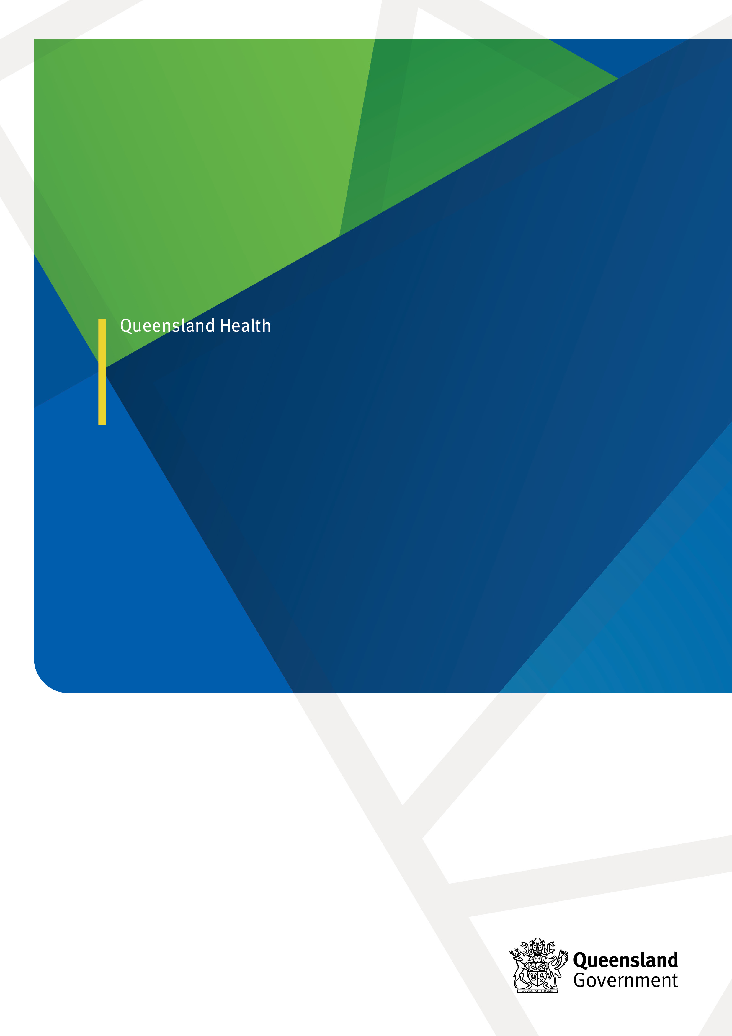

*Note:*

1. *This document is in draft form and the text has not been endorsed.*
2. *The presentation of this document is a guide and will undergo a design and graphics publishing process after endorsement.*
3. *Footnotes will be finalised once the content is finalised.*

QUEENSLAND STI PLAN

2030

# Minister’s Statement

**First Nations Acknowledgment Statement**

Queensland Health respectfully acknowledges the Traditional and Cultural Custodians of the lands, waters and seas across Queensland. We pay our respects to Elders past and present, while recognising the role of current and future leaders in shaping a better health system.

We value the culture, traditions and contributions that the Aboriginal and Torres Strait Islander peoples have made to our communities and recognise that our collective responsibility as government, communities and individuals is to ensure equity and equality, recognition and advancement of Aboriginal and Torres Strait Islander peoples in Queensland in every aspect of our society.

Queensland Health acknowledges the First Nations peoples in Queensland are both Aboriginal peoples and Torres Strait Islander peoples and supports the cultural knowledge, determination and commitment of Aboriginal and Torres Strait Islander communities in caring for their health and wellbeing.

**Alignment with human rights**

Human rights are fundamental to the Blood Borne Virus and Sexually Transmissible Infections (BBVSTI) response in Queensland and grounded in the recognition that all people have the right to health, dignity, and an adequate standard of living. This encompasses the right to comprehensive and inclusive health care, education, and respect for sexual rights. Sexual rights outline that all people have a right to relationships that are safe, pleasurable, free from coercion, stigma, discrimination, and violence. This extends to recognising that the presence or absence of BBV or STIs should not determine someone’s overall health, wellbeing, or self-worth.

Contents

Minister’s Statement 2

About this plan 5

Introduction 6

Guiding principles 8

STIs in Queensland 9

Priority Populations 11

Priority settings 12

Queensland STI Plan 2030 13

Pillar 1: Prevention 14

Pillar 2: Testing 15

Pillar 3: Person-centred treatment and care 16

Pillar 4: Stigma and discrimination 16

Pillar 5: Research, monitoring and governance 17

Indicators 19

Plan on a page – STI in Queensland 2030 22

Abbreviations 25

# About this plan

The *Queensland Sexually Transmissible Infections (STI) Plan 2030* is one of a suite of plans that provide a framework for a coordinated system response to promote good sexual and reproductive health and prevent STI and blood borne viruses in Queensland. These plans are:

* Queensland HIV Plan 2030
* Queensland Hepatitis B Plan 2030
* Queensland Hepatitis C Plan 2030
* Queensland Sexually Transmissible Infections Plan 2030
  + [Queensland Syphilis Action Plan 2023–2028](https://www.health.qld.gov.au/__data/assets/pdf_file/0024/1294503/syphilis-action-plan.pdf)

This suite of Plans are companion documents to the [Queensland Sexual Health Framework](https://www.health.qld.gov.au/public-health/topics/sexual-health/strategy) which adopts the vision of [HEALTHQ32](https://www.health.qld.gov.au/system-governance/strategic-direction/plans/healthq32) to improve the health and wellbeing of all Queenslanders by supporting responsive sexual health services, targeted health promotion and prevention activities, and ensuring priority populations have equitable access to prevention, testing, treatment, and care.

The plans align with the aims of the [First Nations First Strategy 2032](https://www.health.qld.gov.au/system-governance/strategic-direction/plans/first-nations-first-strategy-2032)*.* Queensland Health is committed to closing the gap in inequalities that exist between First Nations and non-First Nations Australians. This includes addressing the disproportionate burden of BBV/STIs experienced by First Nations peoples in Queensland.

The *Queensland STI Plan 2030* and the *Queensland Syphilis Action Plan 2023-2028* (QSAP) present a whole of system approach to operationalise statewide responses to reducing STIs, including syphilis (in pregnancy and congenital syphilis). They are synergistic and build on the successes of the previous *Queensland STI Action Plan 2019-2022*. The STI plan aligns with national priorities in the *Fifth National STI Strategy 2023–2030 (yet to be published)* and sets out Queensland’s approach to eliminating congenital syphilis, improving access to comprehensive STI testing and treatment uptake.

Queensland Health will undertake a mid-point review in 2027 to assess progress against the 2026 and 2030 targets. This review will enable strategic directions to be refocused as needed, to address ongoing and emerging challenges, and accommodate new evidence-based holistic models of care that respond to the increasing complexities experienced by priority populations.

# Introduction

Sexually transmissible infections (STIs) are a public health challenge in Queensland with rapidly evolving epidemiological patterns and changing risk profiles often linked to social determinants of health, ongoing impact of colonisation and systemic barriers to accessing care[1]. STIs are largely preventable and need to be considered in the context of supporting people to enjoy positive sexual health and wellbeing. Some STIs have been considered infections of the past or affecting only specific populations (e.g., syphilis and gonorrhoea among men who have sex with men or in outbreak areas or First Nations communities) however the prevalence of these infections have recently risen significantly in other populations.

Specialist sexual health care is available from public sexual health services and has often focused on more complex presentations or HIV prevention, treatment, and long-term care with less capacity for asymptomatic STI testing appointments and follow up. Public sexual health services are not available outside cities or regional centres unless they offer outreach initiatives and models of care.

Whilst the majority of common STIs are diagnosed in General Practice, there are many opportunities for integrating sexual health support and testing within existing settings that already provide trusted and non-judgmental services for people experiencing hardship or disadvantage or who are affected by social and institutional factors such as stigma, discrimination, homelessness or housing instability, intimate partner or family violence, incarceration, or problematic drug or alcohol use.

This plan focuses on more common notifiable STIs (e.g. chlamydia, gonorrhoea, syphilis), emergent STIs (e.g. mpox), considers changing epidemiology, impact on priority populations with specific STIs (e.g. trichomoniasis, lymphogranuloma venereum), the monitoring of antimicrobial resistance (AMR) and the intersection with reproductive health (e.g. contraception and termination of pregnancy).

Queensland Health is committed to supporting individuals to achieve optimal sexual health and well-being. STIs are largely preventable and, in most cases, can be effectively treated or managed. If left untreated, STIs pose significant health risks including reproductive health issues, adverse pregnancy outcomes, neonatal infections, cancer, and increased risk of other infections, including HIV. Preventing, routinely testing for, and treating STIs underpin the public health approach to promoting optimal sexual health and wellbeing.

Key successes under the previous plan include:

* Recurrent investment in workforce and STI prevention activities initially funded through the *North Queensland Aboriginal and Torres Strait Islander STI Action Plan 2016–2021* with demonstrable reductions in infectious syphilis and congenital syphilis in this region.
* Development of approaches to reducing STI transmission, including development and update of consumer awareness and education campaigns, clinical training and resources:
  + [Queensland Syphilis in Pregnancy Guidelines](https://www.health.qld.gov.au/__data/assets/pdf_file/0035/736883/g-sip.pdf) developed December 2018, and the statewide guideline implementation project in 2020
  + [Stop the Rise of STIs](https://stoptherise.initiatives.qld.gov.au/stis) public awareness campaign focusing on young people (launched 2018 and 2020) with a new targeted website developed
  + Targeted syphilis awareness campaigns and education for priority populations: [Lady Peeps](https://www.true.org.au/resources/lady-peeps) , [Let’s Treat Syphilis](https://letstreatsyphilis.info/), and the [Antenatal Sexual health Kit (ASK)](https://www.true.org.au/professional-learning/full-course-catalogue/course-description?eventtemplate=62-antenatal-sexual-health-kit-ask-selfpaced) training for midwives
  + Sex and Drugs [eLearning](https://insight.qld.edu.au/toolkits/sex-and-drugs/detail) modules and resources for Alcohol and other Drug (AOD) workers developed in 2022
  + Annual (other than 2021) Deadly Sex Congress for Aboriginal and Torres Strait Islander Health Workers and Practitioners
  + Development of the [STI/BBV testing tool for asymptomatic people](https://www.health.qld.gov.au/__data/assets/pdf_file/0025/726523/sti-bbv-testing-tool-30082024.pdf) in 2018, with updates in 2019, 2020, and 2024.
  + Mpox response including prevention messaging for at-risk groups and roll-out of mpox vaccination services statewide.
* Enhanced testing services
  + Online test requests for a [free chlamydia and gonorrhoea urine test](https://www.health.qld.gov.au/clinical-practice/guidelines-procedures/sex-health/13health-webtest) available for people who experience access barriers to a health service (13HEALTH Webtest)
  + [RAPID](https://www.rapid.org.au/) syphilis, chlamydia and gonorrhoea point of care testing service for gay, bisexual and other men who have sex with men (GBMSM).
* Enhanced treatment uptake
  + Review of the Aboriginal and Torres Strait Islander STI drug replacement program, expansion of eligibility to other populations at risk, introduction of doxycycline treatment for chlamydia, and development of a new [webpage](https://www.health.qld.gov.au/clinical-practice/guidelines-procedures/sex-health/sti-drug-replacement-program)
  + Benzathine benzylpenicillin (Bicillin LA®) listed on the Emergency Drug Supply Schedule (Prescriber’s Bag) in Queensland in 2019.
* Surveillance, monitoring, research and evaluation initiatives
  + Congenital syphilis case review overseen by the Queensland Maternal and Perinatal Quality Council and Clinical Excellence Queensland
  + Investment to increase regional contact tracing capacity in five Hospital and Health Services (HHS), with contact tracing activity monitoring processes also established
  + Establishment of the Queensland Sexual Health Clinical Network within Clinical Excellence Queensland with working groups established for:
    - Workforce and infrastructure planning
    - Contact tracing
    - Nurse credentialing and authorisation
    - Termination of pregnancy
    - Gender diversity
  + Implementation of Rounds 2–4 (2019–2021) Sexual Health Research Fund under the auspices of the *Queensland Sexual Health Strategy 2016–2021*.
  + Advocacy for the decriminalisation of sex work in Queensland (with legislation coming into effect 1 August 2024).

# Guiding principles

The *Queensland STI Plan 2030* is underpinned by the Guiding Principles of the *Fifth National STI Strategy 2023 – 2030*:

* Person-centred response
* Partnership
* Human rights
* Health equity
* Health promotion and prevention
* Access and quality health service
* Harm reduction
* Shared responsibility
* Commitment to evidence-informed, enabling policies and programs
* Multi-sectoral partnership and collaboration.

# STIs in Queensland

In Queensland, common STIs include chlamydia, gonorrhoea, herpes simplex virus, genital warts and syphilis.

Other STIs such as lymphogranuloma venereum and donovanosis (notifiable) and trichomoniasis and mycoplasma genitalium (not notifiable) are also of interest in Queensland.

Mpox is an emerging STI of concern. Transmission in Australia is primarily through sexual contact, with cases predominantly occurring in GBMSM, however cases are now being seen in women. The World Health Organization (WHO) declared the mpox outbreak a public health emergency of international concern (PHEIC) on 14 August 2024.

Between 24 June 2022* and 31 December 2023, there were 8 notifications of mpox in Queensland (6 in 2022 and 2 in 2023).

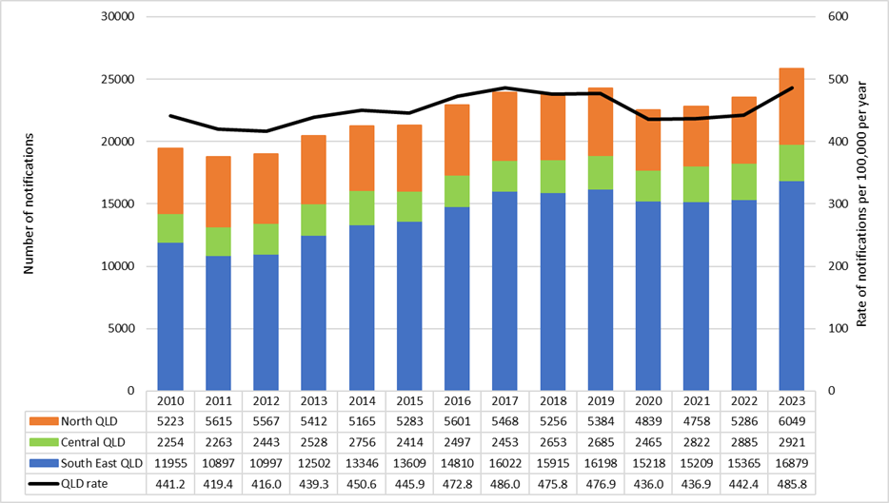

*Fig 1: Number and rate (per 100,000 population per year) of chlamydia notifications in Queensland, by region, 2010–2023*

* Snapshot analysis of Figure 1

* Mpox became notifiable in Queensland on 24 June 2022

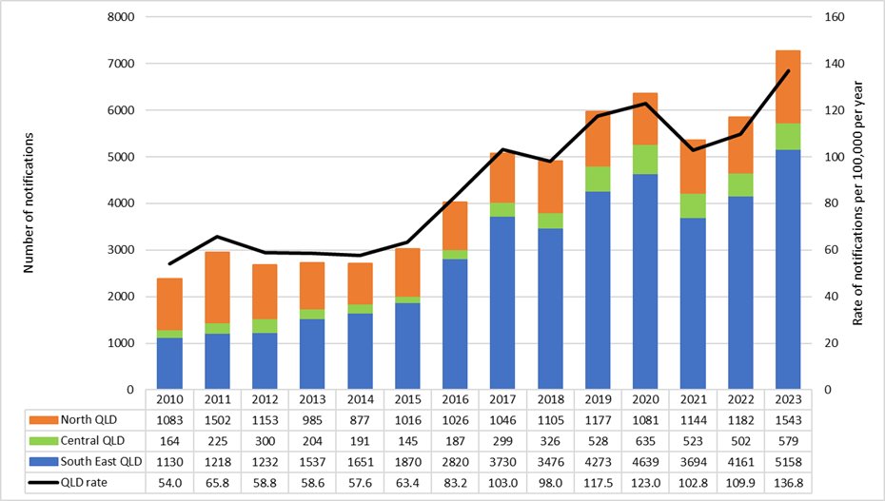

*Fig 2: Number and rate (per 100,000 population per year) of gonorrhoea notifications in Queensland, by region, 2010–2023*

* Snapshot analysis of Figure 2

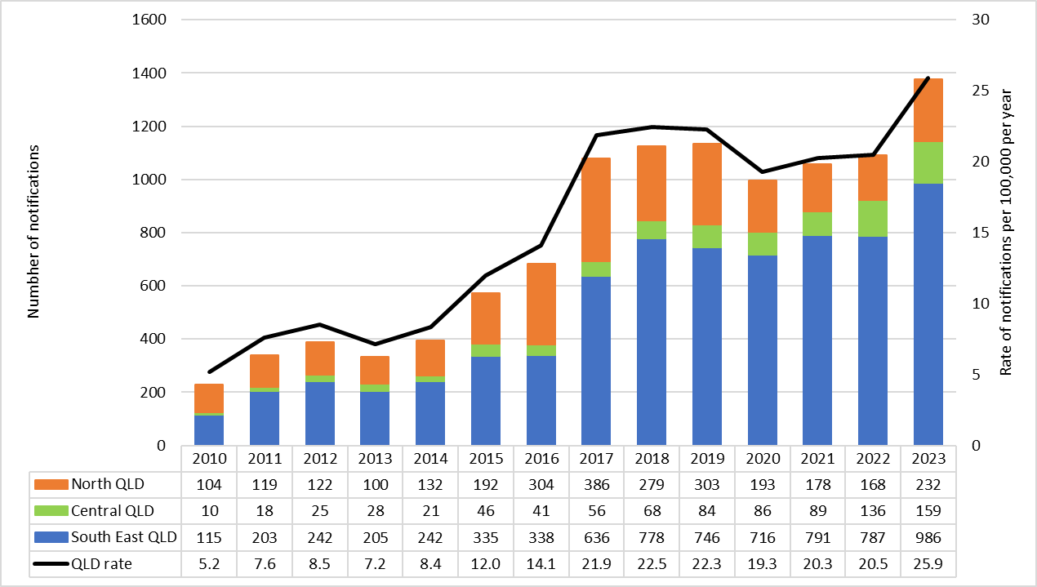

*Fig 3: Number and rate (per 100,000 population per year) of infectious syphilis notifications in Queensland, by region, 2010–2023*

* Snapshot analysis of Figure 3

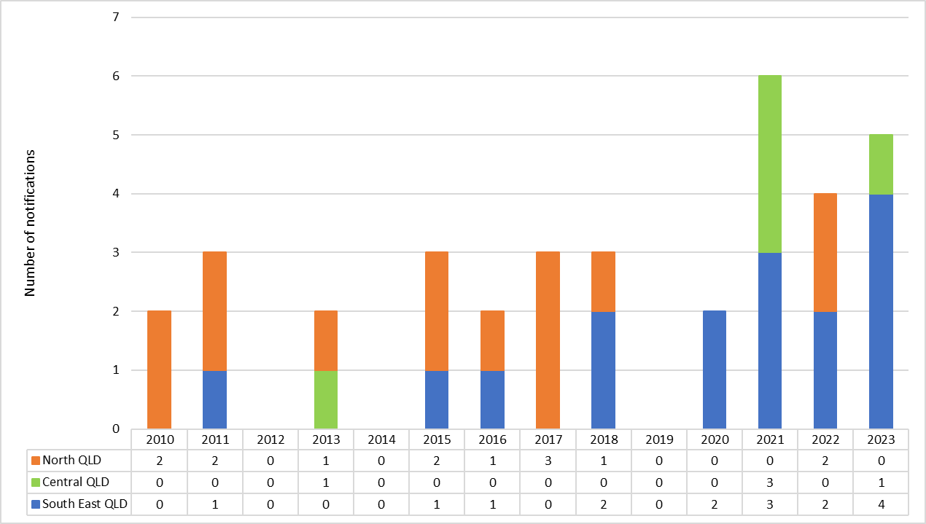

*Fig 4: Number of congenital syphilis notifications in Queensland, by region, 2010–2023*

* Snapshot analysis of Figure 4

# Priority Populations

While anyone can acquire STIs, there are some populations disproportionally impacted, or who may be at higher risk, including:

**Highest priority population**

* First Nations peoples
* Gay, bisexual, and other men who have sex with men (GBMSM)
* Women of reproductive age (15–44 years) and those who are pregnant.[2]

**Other populations of high priority**

* Clients of alcohol or other drug services
* Partners of highest priority populations
* People from culturally and linguistically diverse (CALD) backgrounds, including people born overseas and international students
* Seasonal workers, including those working under the Pacific Australia Labour Mobility (PALM) Scheme
* People in custodial settings
* People living with mental health issues
* People who are affected by socio-economic hardship or disadvantage, such as homelessness, or have no fixed home
* People who are trans and gender diverse
* People who have had an STI within the previous 12 months
* People who are ineligible for Medicare, including seasonal workers
* Sex workers
* Young people.

Consistent with flexible and responsive public health initiatives, this plan notes that people may identify with more than one priority population. Public health engagement with priority populations should embrace diversity in cultural, sexual and gender identities. The provision of culturally appropriate and gender-sensitive sexual healthcare to trans and gender-diverse people requires tailored approaches, particularly for Sistergirls, Brotherboys and trans mob.

# Priority settings

Priority settings are those which provide an opportunity to engage with priority populations and other people who may be at risk of STI transmission. These include:

* Aboriginal and Torres Strait Islander Community Controlled Health Organisations
* Antenatal services
* Community-based and peer-based organisations
* Community pharmacies
* Custodial settings
* Alcohol and other drug services
* Sex on premises venues (SoPVs)
* Emergency departments and infectious diseases outpatient clinics
* General Practice
* Homelessness services
* Mental health services
* Multi-cultural and refugee health services
* Sexual health and gender clinics
* Schools and youth health services.

This plan aims to integrate behavioural and primary care services to improve patient outcomes and remove barriers to engagement and retention in STI treatment and care. It is acknowledged that people in custodial settings experience increased risk of infection as evidence-based prevention methods including condoms are not currently available (at the time of publishing) in Queensland correctional centres.

# Queensland STI Plan 2030

**Vision:** By 2030, congenital syphilis will be eliminated in Queensland, other STIs will be less impactful, and people will be able to access culturally safe treatment and care, live free from stigma and discrimination, and achieve their full potential for sexual health and wellbeing across their lifespan. This vision includes all people, regardless of age, sex, gender identity, sexual orientation, race, ethnicity, geographic location, or socioeconomic circumstance.

**Goals:**

* Reduce STI transmission and related morbidity for all priority populations, in particular people who can become pregnant
* Eliminate congenital syphilis
* Integrate person-centred systems for better sexual and reproductive health for all
* Increase awareness and understanding of STIs as part of sexual and reproductive health for all
* Reduce the negative impact of health inequities, stigma, discrimination, and legal and human rights issues on people’s health
* Support research and activities that strengthen antimicrobial stewardship for STIs.

**Targets for 2026:**

* Establish baseline data for people accessing antenatal care who also receive comprehensive STI screening during pregnancy in accordance with guidelines
* Zero new congenital syphilis notifications
* Reduction in infectious syphilis, gonorrhoea, chlamydia and mpox notifications, compared to 2023 baseline.
* 100% of targeted projects demonstrate evidence of appropriate consultation with members of relevant priority populations or their representative community organisations
* Establish a baseline of the number of doctors, nurses and health workers working in Queensland Health sexual health services who have obtained Contact Tracing Officer appointment under the *Public Health Act 2005*
* Establish baseline data on the percentage of Queensland institutes of higher education who have embedded sexual health, STI information and awareness of stigma within pre-service training and medical school curricula and other health-related fields (such as pharmacy, nursing, and midwifery)
* Establish baseline data of the percentage of secondary schools delivering Relationship and Sexuality Education (RSE) with quality and comprehensive STI content
* Establish a baseline to measure the number of healthcare professionals accessing STI/BBV stigma and discrimination education
* 25% of positive gonorrhoea notifications undergo AMR testing (an increase of 5%).

**Targets for 2030:**

* Sustained zero congenital syphilis notifications and confirmed elimination
* Further reduction of infectious syphilis, gonorrhoea, chlamydia and mpox notifications from 2026 levels
* 100% of doctors, nurses and health workers working in Queensland Health sexual health services have obtained Contact Tracing Officer appointment under the *Public Health Act 2005*
* Increase the number of healthcare professionals accessing STI/BBV stigma and discrimination education, by a minimum of 5% from 2026 levels
* 30% of positive gonorrhoea notifications undergo AMR testing (further increase of 5% from 2026 levels).

# Pillar 1: Prevention

STI prevention is achieved through the complex interaction of public awareness, tools to support healthcare professional practice, community access to services, resources and interventions.

**Priority actions:**

**1.1 Increase awareness of STIs**

* Implement and evaluate co-designed culturally and linguistically appropriate campaigns, interventions, and resources to provide education about comprehensive sexual health promotion, STI prevention and STI-related stigma and discrimination.
* Maintain and update Queensland Health online STI information sources and actively promote to partners and stakeholders
* Work with partners, including Primary Health Networks (PHN), to expand reach of STI prevention, testing, treatment and contact tracing messaging to primary care providers.

**1.2 Partner with Aboriginal and Torres Strait Islander communities to promote STI messaging and address health inequities**

* Improve culturally appropriate messaging that supports access to STI prevention, testing and treatment for Aboriginal and Torres Strait Islander people through active partnerships with Aboriginal and Torres Strait Islander organisations.
* Support partnerships between HHS, Non-Government Organisations (NGOs) and Aboriginal and Torres Strait Islander Community Controlled Health Organisations (ATSICCHOs) to promote STI care across services.

**1.3 Support activities focused on STI prevention and onward transmission**

* Promote easy access to and use of condoms with lubricant and other safer sex strategies, while reinforcing the central role of condoms in STI prevention
* Promote the benefits of regular testing, treatment, and management which includes care for sexual partner(s) of people diagnosed with STIs
* Complete and implement the Queensland STI/BBV Contact Tracing Guideline and associated training packages to support contact tracing and partner notification
* Provide contact tracing and encourage partner notification for people diagnosed with STIs and their sexual and/or injecting equipment-sharing partner(s).

**1.4 Vaccines and other biomedical approaches**

* Facilitate partnerships to improve uptake of mpox vaccination in GBSMSM e.g., through outreach clinics in SoPVs
* Achieve and maintain HPV adolescent vaccination coverage of 85%
* Support the rollout of new vaccines consistent with Australian Immunisation Handbook recommendations and technologies approved by the Therapeutic Goods Administration (TGA) to prevent STIs among priority populations.

# Pillar 2: Testing

Advances in STI point of care testing technologies and public acceptability of point of care, home and online testing enhance opportunities to increase testing for the general public and priority populations. Increased and enhanced testing aims to reduce STI-related morbidity for all. Queensland Health will continue to fund free point of care STI testing at sexual health clinics and peer-led community organisations, whilst exploring opportunities for additional testing types and sites across Queensland.

**Priority actions:**

**2.1. Normalise and embed STI testing across diverse settings**

* Promote and improve access to a range of innovative STI testing methods in a range of settings, including opportunistic testing e.g. Emergency Departments, AOD service settings, homelessness services or places of refuge/shelter, point of care testing, online and/or self-collected sample testing.
* Support expansion of programs to deliver education, prevention and testing in school-based and non-traditional educational settings.
* Maintain the 13HEALTH Webtest program for online chlamydia and gonorrhoea testing and review the service model as required.
* Support service improvement and quality assurance processes to normalise and enhance STI testing and treatment during pregnancy.
* Facilitate opportunities for STI prevention, testing and treatment in Queensland Corrective Services in alignment with priority action 1.3 of the Queensland Hepatitis C Plan 2030.

**2.2 Supporting primary care**

* Support access to free STI testing through public sexual health services with support for individuals using a preferred/alternative name or alias.
* Support activities to enhance and strengthen STI testing in General Practice both opportunistically and as part of routine comprehensive sexual health checks.
* Support the inclusion and promotion of sexual health check-ups and STI testing as part of Medicare Benefits Schedule (MBS) 715 Aboriginal and Torres Strait Islander Health Checks.

# Pillar 3: Person-centred treatment and care

Queensland Health recognises the importance of a person-centred approach to STI prevention, treatment and care. This involves applying a more holistic approach to care that acknowledges the wider social, psychological and cultural factors that may affect an individual and their experience with healthcare.

**Priority actions:**

**3.1 Improved access to treatment and care**

* Maintain the Aboriginal and Torres Strait Islander STI drug replacement program for chlamydia, gonorrhoea and trichomoniasis
* Enhance nurse-led models of care, telehealth and other prescribing methods to improve access to care for in reach, outreach, rural, regional and remote settings
* Support the integration of contraception and termination of pregnancy care where appropriate in comprehensive sexual and reproductive health care.

**3.2** **Strengthen healthcare workforce capacity**

* Advocate for public sexual health workforce to work to top of scope
* Advocate for the inclusion of comprehensive sexual health and STI prevention, treatment and management information in the curricula of health workforce education and training programs
* Support and enable a highly skilled multidisciplinary workforce that is respectful of and responsive to the needs of people with STIs, and works to normalise STI testing as part of usual care
* Support the Aboriginal and Torres Strait Islander workforce through enhanced capacity and opportunities for sexual health and STI prevention, testing and management education
* Support the development of education focused on emergent clinical needs, legislative and regulatory changes.

# Pillar 4: Stigma and discrimination

Individuals diagnosed with an STI continue to experience stigma and discrimination related to their STI, including experiencing negative treatment from health workers.[3] Stigma can influence individuals seeking immediate treatment and care for their sexual health concerns, which can impact long term engagement in care and health outcomes related to fertility and wellbeing. Queensland Health is committed to increasing awareness and understanding of STIs through community engagement and healthcare professional education to support the reduction of stigma and discrimination related to STIs.

**Priority actions:**

**4.1 Reduce STI-related stigma and discrimination in the healthcare workforce**

* Support the provision of respectful and responsive STI prevention, testing and treatment programs and services through promotion of stigma and discrimination education and training for healthcare professionals.
* Establish a culturally responsive workforce by ensuring there is an organisational commitment to cultural awareness and safety and establishing mechanisms to recognise, address, and prevent racism at the individual and organisational levels.

**4.2 Reduce STI-related stigma and discrimination in the community**

* Promote community education and other initiatives to address misconceptions and reduce STI-related stigma and discrimination, particularly for priority populations.
* Promote the creation and dissemination of accurate STI-related messaging in the media and counter associated misinformation.

# Pillar 5: Research, monitoring and governance

Research develops the evidence base which informs the public health policies underlying Australia’s successful response to STIs. Monitoring and governance track the progress of public health initiatives and ensure responsiveness to emerging challenges and transmission clusters. Queensland Health will continue to strengthen health information systems to provide accurate, timely and granular data essential for strategic planning and program improvement, resource allocation and health service delivery, ensuring stakeholders have access to relevant information to support prevention, detection and management activities.

**Priority actions:**

**5.1 Strengthen healthcare systems**

* Support the capacity of health infrastructure to respond effectively to outbreaks and epidemics at regional and local levels by providing guidance and protocols where appropriate.
* Support the implementation of both STI Plan and QSAP activities.
* Develop and implement a QSAP performance framework to support QSAP reporting, monitoring and evaluation.

**5.2 Improve statewide STI notification, data collection and reporting**

* Prioritise access to, monitoring, reporting and publishing of statewide STI notification and testing data.
* Consider initiatives to make syphilis testing notifiable in Queensland.
* Increase accessibility to relevant STI notification and testing data by exploring new real time dashboard and reporting formats to enable rapid responses to localised increases in notifications.
* Identify and resolve gaps in surveillance data for measuring and monitoring the implementation of this Plan, particularly in relation to demographic data including Aboriginal and Torres Strait Islander status, country of birth or language spoken at home, and data related to trans and gender diverse people.
* Work with partners, including the Sexual Health Clinical Network, to advocate for a comprehensive, integrated information and communication technology (ICT) solutions for Queensland’s sexual health services to support service level planning and reporting.

**5.3 Respond to emerging issues**

* Progress the *Gonorrhoea in Queensland* epidemiology report and other planning to respond to increasing gonorrhoea notifications in Queensland
* Review and implement the Standard Operating Procedure for critical antimicrobial resistant gonorrhoea infection notifications in Queensland
* Monitor mpox notifications in Queensland, consider the emerging national and global situation and work with partners to coordinate consistent and aligned prevention, testing and treatment messaging
* Monitor, plan, collaborate with partners and respond to sexual health needs of seasonal workers, including those working under the Pacific Australia Labour Mobility (PALM) Scheme
* Investigate trichomoniasis prevalence in Queensland and develop a plan to respond
* Strengthen surveillance systems by refining processes for identifying, monitoring and collaboratively addressing emerging issues including AMR
* Monitor and address the legislative, regulatory and policy environment which impact access to STI testing, treatment, management and workforce scope of practice.
* Support research and develop guidelines for antibiotic prophylaxis against bacterial STIs for priority populations, where proven to be safe and effective

# Indicators

To ensure monitoring and governance activities are supported, Queensland Health will seek to establish a BBVSTI Committee of key stakeholder representatives including sexual health services, community organisations, research bodies and the Department of Health. This Committee will meet bi-annually for the life of this plan.

|  |  |  |  |
| --- | --- | --- | --- |
| Pillars | Indicator | Data Source/responsible agencies | Frequency |
| Prevention | Analytics and evaluation of public facing website material or campaigns, including evidence of collaboration with priority populations | Strategic Communications Branch and Communicable Diseases Branch, Department of Health | Annual |
| Evaluation outcomes of STI-related social media (Facebook, Instagram, YouTube, Twitter) number of posts, audience engagement | Strategic Communications Branch and  Communicable Diseases Branch, Department of Health | Annual |
| Number and evaluation outcomes of targeted online community campaigns to raise awareness of STIs in specific settings or among specific populations | Funded service provider reports | As relevant |
| Number of condoms distributed by funded service provider programs | Funded service provider reports | Annual |
| 85% HPV adolescent vaccination coverage is achieved | Communicable Diseases Branch, Department of Health | Annual |
| Number of schools enrolled in General Practitioner (GP) in State Schools Program is maintained | Department of Education | Annual |
| Testing | Queensland STIBBV testing tool is kept up to date (aligned to STI Management Guidelines), and available online | Communicable Diseases Branch, Department of Health | Annual |
| Number of STI online risk assessments completed, tests requested, positive chlamydia and gonorrhoea results reported by 13HEALTH Webtest | Health Contact Centre, Queensland Ambulance Service | Annual |
| Number and type of Queensland Health and NGO STI outreach service delivery initiatives which provide STI testing, treatment and management | Funded service provider reports  Sexual health sector advice | Annual |
| Number of STI point of care testing sites and number of STI point of care tests undertaken | Commonwealth syphilis POCT program  Funded service provider reports | Annual |
| Person-centred treatment and care | Evidence of appropriate consultation with priority populations or their representative community organisations for targeted projects | Funded service provider reports, surveys and advisory group documents | Annual |
| Number of HHS, NGO and ATSICCHOs engaged, and type of engagement | Communicable Diseases Branch, First Nations Health Office, Department of Health | Annual |
| Number of sexual health professionals who have completed the online Queensland STI/BBV contact tracing training modules | Communicable Diseases Branch, Department of Health | Annual |
| Number of eligible services enrolled and actively participating in the Aboriginal and Torres Strait Islander STI drug replacement program and quantity of medication delivered to participating services | Communicable Diseases Branch and Central Pharmacy, Department of Health | Annual |
| Number of STI education sessions delivered and evaluated for health workforce in Queensland which provided education about STI prevention, testing, treatment and management | Funded service provider reports  Reporting via QSAP mechanisms | Annual |
| Number of sexual health professionals who have obtained Contact Tracing Officer appointment under the *Public Health Act 2005* | Centre for Public Health Regulatory Excellence, Department of Health | Annual |
| Number of completions of online Insight Sex and Drugs learning modules | Funded service provider reports | Annual |
| Stigma and discrimination | Number of healthcare professionals completing STI/BBV stigma and discrimination education | Funded service provider reports  iLearn user reports | Annual |
| National Stigma Indicators Monitoring Project – explore opportunities to access Queensland-specific data from this dataset including:  -Stigma indicator (percentage of participants reporting stigma or discrimination in relation to their STI in the past 12 months)  -Percentage of participants reporting negative/different treatment from health workers in the past 12 months  -Percentage of participants reporting different strategies to avoid experiencing stigma/discrimination in health care settings | UNSW Centre for Social Research in Health | When available |
| Research, monitoring and governance | Number of BBVSTI Committee meetings held | Communicable Diseases Branch, Department of Health | Biannual |
| Percentage of gonorrhoea notifications that undergo antimicrobial susceptibility testing by culturing. | Pathology Queensland, QPHaSS | Annual |
| Weekly, quarterly, year-to-date and annual reporting of chlamydia, gonorrhoea, mpox and infectious and congenital syphilis notifications and syphilis testing data when available. | Notifiable Conditions System, Public Health Intelligence Branch and Communicable Diseases Branch, Department of Health | Weekly, Quarterly, Annual |
| BBVSTI notification and testing data by HHS is available via a reporting dashboard | Public Health Intelligence Branch | Annual |
| Response plans for trichomoniasis and gonorrhoea developed and implemented | Communicable Diseases Branch, Department of Health | Annual |
| Percentage of congenital syphilis cases for which local analysis report was provided to the Patient Safety and Quality Improvement Service. | Patient Safety and Quality Improvement Service, Clinical Excellence Queensland  Epidemiology and Research Unit, Public Health Intelligence Branch | Annual |
| Number of Queensland Health funded STI research activities commenced, completed and outcomes shared. | QLD Sexual Health Research Fund, Communicable Diseases Branch, Department of Health | Annual |

# Plan on a page – STI in Queensland 2030

*By 2030, congenital syphilis will be eliminated in Queensland, other STIs will be less impactful, and people will be able to access culturally safe treatment and care, live free from stigma and discrimination, and can achieve their full potential for health and wellbeing across their lifespan.*

**NOTE – this information will be displayed on one page, serving as a snapshot of the entire STI Plan.**

**Priority settings:** Aboriginal and Torres Strait Islander Community Controlled Health Organisations; Antenatal services; Community-based and peer-based organisations; Community pharmacies; Custodial settings; Alcohol and other drug services; Sex on premises venues; Emergency departments and infectious diseases clinics; General Practice; Homelessness services; Mental health services; Multi-cultural and refugee health services; Sexual health and gender clinics; Schools and youth health services

**Priority populations:** First Nations peoples; Gay, bisexual, and other men who have sex with men; Women of reproductive age (15–44 years) and those who are pregnant; Clients of alcohol or other drug services; Partners of highest priority populations; People from culturally and linguistically diverse backgrounds, including people born overseas and international students; People in custodial settings; People living with mental health issues; People who are affected by socio-economic hardship or disadvantage, such as homelessness, or having no fixed home; Trans and gender diverse people; People who have had an STI within the previous 12 months; People who are ineligible for Medicare, including seasonal workers; Sex workers; Young people

|  |  |  |
| --- | --- | --- |
| Pillar | Priority actions | Indicators of success |
| 1. Prevention | * 1. Increase awareness of STIs   2. Partner with Aboriginal and Torres Strait Islander communities to promote STI messaging and address health inequities   3. Support activities focused on STI prevention and onward transmission   4. Vaccines and other biomedical approaches | * Analytics and evaluation of public facing website material or campaigns, including evidence of collaboration with priority populations * Evaluation outcomes of STI-related social media (Facebook, Instagram, YouTube, Twitter)- number of posts, audience engagement * Number and evaluation outcomes of targeted online community campaigns to raise awareness of STIs in specific settings or among specific populations * Number of condoms distributed by funded service provider programs * 85% HPV adolescent vaccination coverage is achieved * Number of schools enrolled in GP in State Schools Program is maintained |
| 1. Testing | * 1. Normalise and embed STI testing across diverse settings   2. Supporting primary care | * Queensland STIBBV testing tool is up to date, and available online * Number of STI online risk assessments completed, tests requested, positive chlamydia and gonorrhoea results reported by 13HEALTH Webtest * Number and type of Queensland Health and NGO STI outreach service delivery initiatives which provide STI testing, treatment and management * Number of STI point of care testing sites * Number of STI point of care tests undertaken |
| 1. Person-centred treatment and care | * 1. Improved access to treatment and care   2. Strengthen healthcare workforce capacity | * Evidence of appropriate consultation with priority populations or their representative community organisations for targeted projects * Number of HHS, NGO and ATSICCHOs engaged, and type of engagement * Number of sexual health professionals who have completed the online Queensland STI/BBV contact tracing training modules * Number of eligible services enrolled and actively participating in the Aboriginal and Torres Strait Islander STI drug replacement program and quantity of medication delivered to participating services * Number of STI education sessions delivered and evaluated for health workforce in Queensland which provided education about STI prevention, testing, treatment and management * Number of sexual health professionals who have obtained Contact Tracing Officer appointment under the Public Health Act 2005 * Number of completions of online Insight Sex and Drugs learning modules |
| 1. Stigma and discrimination | * 1. Reduce STI-related stigma and discrimination in the healthcare workforce   2. Reduce STI-related stigma and discrimination in the community | * Number of healthcare professionals completing STI/BBV stigma and discrimination education * National Stigma Indicators Monitoring Project – explore opportunities to access Queensland-specific data from this dataset including:   + Stigma indicator (percentage of participants reporting stigma or discrimination in relation to their STI in the past 12 months)   + Percentage of participants reporting negative/different treatment from health workers in the past 12 months   + Percentage of participants reporting different strategies to avoid experiencing stigma/discrimination in health care settings. |
| 1. Research, monitoring and governance | * 1. Strengthen healthcare systems   2. Improve statewide STI notification, data collection and reporting   3. Respond to emerging issues | * Number of BBVSTI Committee meetings held * Percentage of gonorrhoea notifications that undergo antimicrobial susceptibility testing by culturing. * Weekly, quarterly, year-to-date and annual reporting of chlamydia, gonorrhoea, mpox and infectious and congenital syphilis notifications and syphilis testing data when available. * BBVSTI notification and testing data by HHS is available via a reporting dashboard * Response plans for trichomoniasis and gonorrhoea developed and implemented * Percentage of congenital syphilis cases for which local analysis report was provided to the Patient Safety and Quality Improvement Service. * Number of Queensland Health funded STI research activities commenced, completed and outcomes shared. |

# Abbreviations

|  |  |
| --- | --- |
| **Acronym** | **Definition** |
| AMR | Antimicrobial resistance |
| AOD | Alcohol and other drugs |
| ASHM | Australasian Society for HIV, Viral Hepatitis and Sexual Health Medicine |
| ATSICCHO | Aboriginal and Torres Strait Islander Community Controlled Health Organisation |
| BBV | Blood-borne virus |
| CALD | Culturally and linguistically diverse |
| GBMSM | Gay, bisexual and other men who have sex with men |
| GP | General Practitioner |
| HHS | Hospital and Health Service |
| ICT | Information Communication and Technology |
| MBS | Medicare Benefits Schedule |
| NGO | Non-Government Organisation |
| PHEIC | Public Health Emergency of International Concern |
| PHN | Primary Health Networks |
| QSAP | Queensland Syphilis Action Plan |
| RSE | Relationship and sexuality education |
| SoPV | Sex on premises venue |
| STI | Sexually transmissible infection |
| TGA | Therapeutic Goods Administration |
| WHO | World Health Organization |

QUEENSLAND STI PLAN - 2030

Published by the State of Queensland (Queensland Health), SELECT DATE SELECT DATE

This document is licensed under a Creative Commons Attribution 3.0 Australia licence.

To view a copy of this licence, visit creativecommons.org/licenses/by/3.0/au

© State of Queensland (Queensland Health) 2023

You are free to copy, communicate and adapt the work, as long as you attribute the State of Queensland (Queensland Health).

For more information contact:

Communicable Diseases Branch, Department of Health, PO Box 2368, FORTITUDE VALLEY BC 4006, email BBVCDU@health.qld.gov.au.

An electronic version of this document is available at www.insert.website.here.com

1. [Babies infected with syphilis are part of a growing tragedy – one that could be easily prevented (theconversation.com)](https://theconversation.com/babies-infected-with-syphilis-are-part-of-a-growing-tragedy-one-that-could-be-easily-prevented-200733?utm_medium=email&utm_campaign=Latest%20from%20The%20Conversation%20for%20August%201%202024%20-%203051231103&utm_content=Latest%20from%20The%20Conversation%20for%20August%201%202024%20-%203051231103+CID_3eb483841a6432f70c58f6a5af508c5f&utm_source=campaign_monitor&utm_term=Babies%20infected%20with%20syphilis%20are%20part%20of%20a%20growing%20tragedy%20%20one%20that%20could%20be%20easily%20prevented)
2. In recognition of diverse gender identities, where the term ‘woman’ or ‘women’ is used, this is inclusive of people who are pregnant or give birth and who may not identify as female.
3. [Stigma snapshot: Sexually transmissible infections 2023 (unsw.edu.au)](https://www.unsw.edu.au/content/dam/images/ada/csrh/research/2024-02-crsh/2024-02-crsh-sexually-transmissible.pdf)