
NZ immunisation social media copy

Tile options:
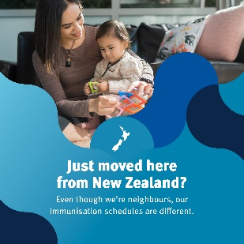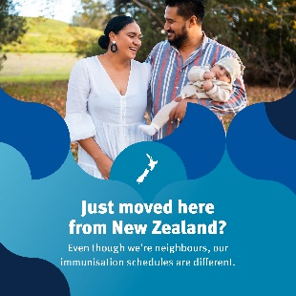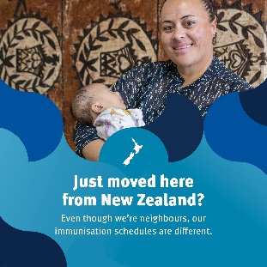
Example post copy:
Even though we're neighbours, our immunisation schedules are different.
While your child may have had all their immunisations in New Zealand, they might not be up to date with the Queensland immunisation schedule.
Talk to your immunisation provider or local doctor to find out if there are any gaps and to create a catch-up schedule to get your child up to date with their immunisations.
Having immunisations on time will give your child the best protection.

Childhood immunisation is a safe, free and effective way to protect your child from serious diseases, now and in the future.

Find out more: https://www.health.gov.au/childhood-immunisation

